

A Project Report on

**Hosptial Management System**

Submitted as a Mini-Project

By

**G Satvik Kalyan (160116733106)**

**B Sharath Chandra (160116733107)**

Under the guidance of

**Smt G Mamatha**

Asst. Professor

Department of CSE

CBIT, Hyderabad

**Department of Computer Science and Engineering**

**Chaitanya Bharathi Institute of Technology**

**Certificate**

This is to certify that the project titled “Hospital Management System” is a bonafide work carried out by G.Satvik Kalyan (160116733106) and B.Sharath Chandra (160116733107), in completion of a mini-project under our guidance and supervision.

The results embodied in this report have not been submitted to any other university or institute for the award if any degree or diploma.

Internal Guide Head of Department

Smt G Mamatha Dr.T.Swami Das

Asst. Professor Department of CSE

Department of CSE CBIT, Hyderabad.

CBIT, Hyderabad

**Acknowledgement**

The satisfaction that accompanies the successful completion of this project would be in complete without the mention of the people who made it possible, without whose constant guidance and encouragement would have made efforts go in vain. We consider ourselves privileged to express gratitude and respect towards all those who guided us through the completion of this project.

I convey thanks to our project guide Smt G Mamatha, Department of Computer Science for providing encouragement, constant support and guidance which was a great help to complete this project successfully

**ABSTRACT**

## 

The Hospital management System is developed to decrease the work that is done manually at Hospital centers. Every single step is done with the help of system, services such as patient records, availability of rooms, inquiries of doctor availability, billing. This Hospital management System will help in reducing lots of paper work and file work in these hospitals which will make easy management of hospital. It will also provide all the latest information to the management about the patient and doctors.

Since we are using ‘JAVA’ language in programming the management application, Using the Hospital management System is as simple as using the personal computer. Since java language is used in formulating the program, It is beneficial to both Health center and the patients. Every step is clearly defined and help is provided throughout the application to the user.

Using this we can know the details of already existing patients by simply entering the serial number or id number of the patient. If the patient is new then the user gives in the information about the patient. In case the patient wants to book a room then from the ‘Availability Of Rooms’ option they can know the types of rooms available. A bill can be printed using the ‘Billing’ option.

**CONTENTS**

List of Figures 6

1. Introduction 7

1.1 Motivation 7

1.2 Objective of the Project 8

1.3 Limitations of the Project 8

2. Analysis 9

2.1 Software Requirements 12

2.2 Hardware Requirements 12

2.3 Flow Chart 13

3. Features 14

4. Implementation and Design 15

5. Testing and Validation 22

5.1 Introduction 22

5.1 Design of Test Cases and Scenarios 22

5.2 Validation 24

5.3 Conclusion 24

6. References 25

7. Appendix 26

**LIST OF FIGURES**

Figure-1: First Figure

Figure-2: Screen related to Patients

Figure-3: Screen to Access Patient Details or to Register a new Patient

Figure-4: Screen to enter Patient Details

Figure-5: Bill Generator

Figure-6: Doctor details

Figure-7: Update doctor status

1. **Introduction**

**1.1 Motivation**

The idea that motivated this project in the earliest stage of its creation was the desire to create something that was not just interesting and informative, but also useful to a diverse and wide range of users. The practicality and utility of a project are essential factors to keep in mind while creating any work that can be called engineering. Hence, the concept of **Hospital Management System** was formed, as it is one that is common enough to be required frequently by people, and important enough to need efficient and proper design.

With this end in mind, it was logically necessary to design an interface-based application, rather than simply a console-based program. It is the author’s belief that even though it is only the front-end of a project, the design of a user interface is of utmost importance to anyone who seeks to make a mark with their project.

The Hospital Management System is targeted to automate the almost all of the processes mentioned above to reduce the clerical labour of the staff working in Hospital both technical and as well as Accounts departments using the software industry’s latest technologies and cost effective tools there by providing the better control to the management by avoiding manual errors etc..,

Further, the idea of levels was an attractive one, as it held the promise of making a quiz interesting and appealing, as well as posing a challenge to the programmer. After deciding to implement a quiz, all the features it must offer were considered and decided.

In all of these ways, the project received its first start from the ground, and it is the author’s hope that it has accomplished all that it set out to accomplish.

**1.2 Objective of the Project**

As mentioned above the main objective of the Project is to simplify the job of managing a store and its maintenance.

This application discusses the initial Figures like login, logout and main menu of the application and other interactive Figures. The application can be accessed by running the main file using a Java Compiler.

The stores operations as per the stores manual have been described as two different processors owing to the complexity and tediousness of the operations by effective division of labour as physical receipts and issue has been the responsibility of Accounts section.

**1.3** **Limitations of the Project**

At this point of time, due to unavailability of a Database, multiple systems cannot work on the same stock i.e. multiple systems cannot perform the billing operations using the same stock.

However, we have made sure that the stock is stored and retrieved whenever the stock changes or the program is closed by saving those information in the files .So that there is no need for the user to enter the details of the stock each time the user this software.

The second limitation is that the java application has to be executed using Command Prompt as no .exe file could be generated using Java.

However, by using a third-party application the program can be started just by a click of an icon on the desktop.

**2. Analysis**

This project is based on programming with **Object Oriented Programming using JAVA.**

Java is actually a platform consisting of three components:

1) Java programming language.

2) Java library of classes and interfaces.

3) Java virtual Machine.

The following sections will say more about these components:

**Java is Portable:**

One of the biggest advantages Java offers is that it is portable. An application written in Java will run on all the major platforms. Any computer with a Java based browser can run the applications or applets written in the Java programming language. A Programmer no longer has to write one program to run on a Macintosh, another program to run on a windows machine, still another to run on a UNIX machine, and so on. In other words, with Java, developers write programs only once. Rather than being compiled in to machine language, which is different for each operating systems and computer architecture, Java code is compiled in to byte codes.

With other languages, the program code is compiled in to a language that the computer can understand; the problem is that other computers with different machine instructions set cannot understand that language. Java code, on the other hand is compiled in to byte codes rather than a machine language. These byte codes go to the Java virtual machine, which executes them directly or translates them in to the language that is understood by the machine running it.

In the summary, these means that with the JDBC API extending Java, a programmer writing Java code can access all the major relational databases on any platform that supports the Java virtual machine.

**Java Is Object-Oriented:**

Java programming language is object oriented, which makes program design focus on what you are dealing with rather than on how you are going to do something. This makes it more useful for programming in sophisticated projects because one can break the things down into understandable components. A big benefit is that these components can then be reused.

Object Oriented languages use the paradigm of classes. In simplest terms, a class includes both the data and the functions to operate on the data, all the data members and functionality of its class. Because of this, you can think of a class as being like template, with each object being a specific instance of a particular type of a class.

The class paradigm allows one to encapsulate data so that specific data values are those using the data cannot see function implementation. Encapsulation makes is possible to make the changes in code without breaking other programs that use that code. If for example the implementation of a function is changed, the change is invisible to the programmer who invokes that function, and it does not affect his/her program, except hopefully to improve it.

Java includes inheritance, or the ability to derive new classes from existing classes. The derived class, referred to as the parent class. A subclass can add new data members to those inherited from the parent class. As far as methods are concerned, the subclass can reuse the inherited methods as it is, change them, and/or add its own new methods.

**Java Makes It Easy To Write Correct Code:**

In addition to being portable and object oriented, java facilitates writing correct code. Programmers spend less time writing java code and a lot less time debugging it. In fact, development time reduces by as much as two thirds

**Graphical User Interface using Swing:**

Swing implements a set of components for building graphical user interfaces (GUIs) and adding rich graphics functionality and interactivity to Java applications. The Swing components are implemented entirely in the Java programming language. The pluggable look and feel lets you create GUIs that can either look the same across platforms *or* can assume the look and feel of the current OS platform (such as Microsoft Windows, Solaris™ or Linux).

Swing is a set of program components for [Java](http://searchsoa.techtarget.com/definition/Java) programmers that provide the ability to create graphical user interface ( [GUI](http://searchwindevelopment.techtarget.com/definition/GUI) ) components, such as buttons and scroll bars, that are independent of the [windowing system](http://searchwinit.techtarget.com/definition/windowing-system) for specific [operating system](http://searchcio-midmarket.techtarget.com/definition/operating-system) . Swing components are used with the Java Foundation Classes ([JFC](http://searchsoa.techtarget.com/definition/Java-Foundation-Classes) ).

[Swing](https://www.programmermart.com/) was developed to provide a more sophisticated set of GUI [components](https://en.wikipedia.org/wiki/Software_component) than the earlier [Abstract Window Toolkit (AWT)](https://en.wikipedia.org/wiki/Abstract_Window_Toolkit). Swing provides a native [look and feel](https://en.wikipedia.org/wiki/Look_and_feel) that emulates the look and feel of several platforms, and also supports a [pluggable look and feel](https://en.wikipedia.org/wiki/Pluggable_look_and_feel) that allows applications to have a look and feel unrelated to the underlying platform. It has more powerful and flexible components than AWT. In addition to familiar components such as buttons, check boxes and labels, Swing provides several advanced components such as tabbed panel, scroll panes, trees, tables, and lists.

**2.1 Software Requirements**

* Any 32-bit or 64-bit operating system that has JDE and JVM
* Environmental Variables set for Classpath and Path
* Any text editor
* A console with access to the Java Compiler.
* Support for Graphical User Interfaces (GUIs)

**2.2 Hardware Requirements**

* Input device to answer questions and select options.
* 32-bit or 64-bit processor
* Sufficient RAM to run the program

**2.3 Flow Chart:**

**Patient**

**Doctor**

**Re**

**Patient Details**

**Doctors Details**

**Patient Registration**

**Doctor Status**

**Billing**

**3. Features:**

**(1) Old patients:**

**patient record:**

name

age

gender

problem

room number

**(2) New patients:**

1. **Add new patient record:**

Adding the details of patients

**(3)Availability of rooms:**

**Type of room:**

* + - * 1. Ac room
        2. Non ac room
        3. General ward

**(4)Details of Doctors:**

* + - * 1. Doctors specialization
        2. Availability

**(5)Billing:**

A .Consulting fee

B .room fee

**4. Implementation and Design:**

DESIGN AND FLOW OF GRAPHICAL USER INTERFACE:

The introductory Screen looks as follows

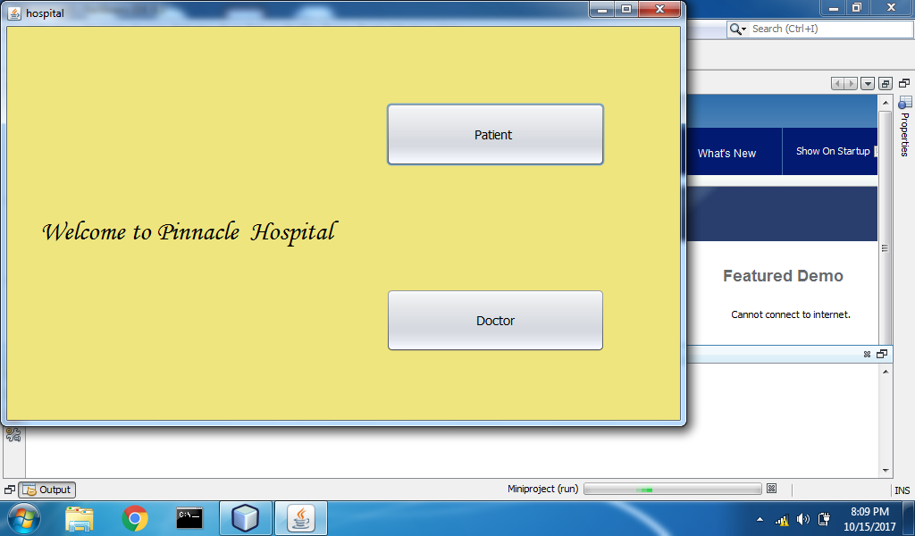

Figure 1

This Figure is the initial window which allows you to select in between Patient and Doctor tabs. On clicking on Patient tab new Screen pops open.

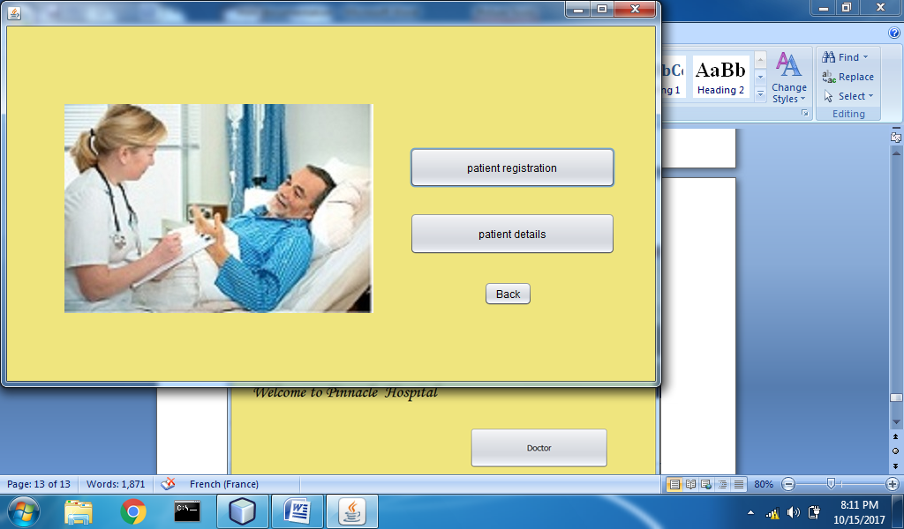

Figure 2

On this Figure you can select to Register a new patient or Details of already existing Patients can be viewed.

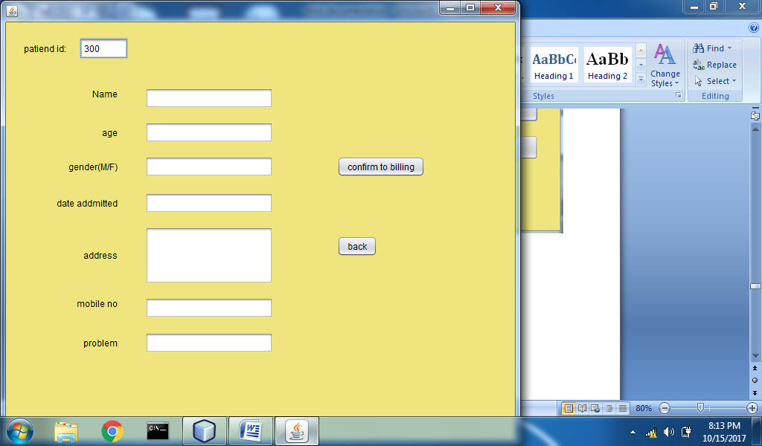

Figure 3

Details of the patients such as Name,age,gender,address are to be entered in this Figure all fields are mandatory and they give an pop up window asking to not leave the fields empty.

Mobile numbers and age are to be in numericals.If any other character is entered it shows an error window.Mobile number must be 10 digits an error window pops up if number of digits in the mobile number is less or even greater than 10.

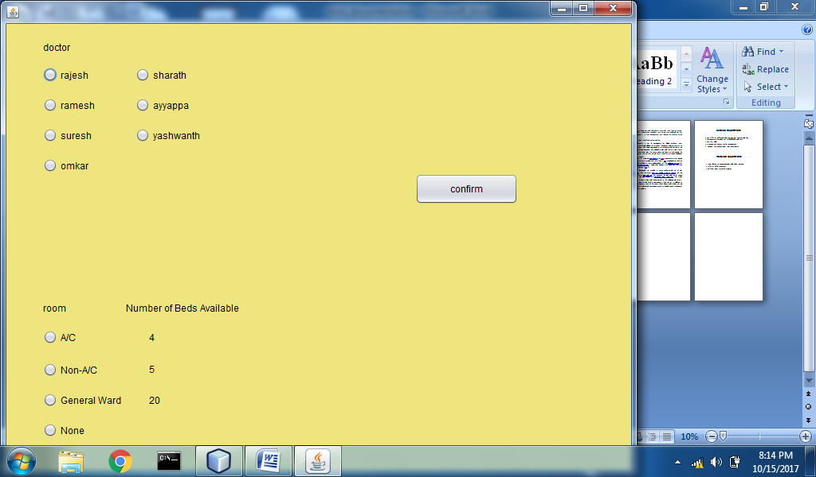

Figure 4

When we enter this Figure there is no going back into registration window.

Here we have to select the doctor and the room if required.

Here again one radio button of both options must be selected or else it shows an error window.

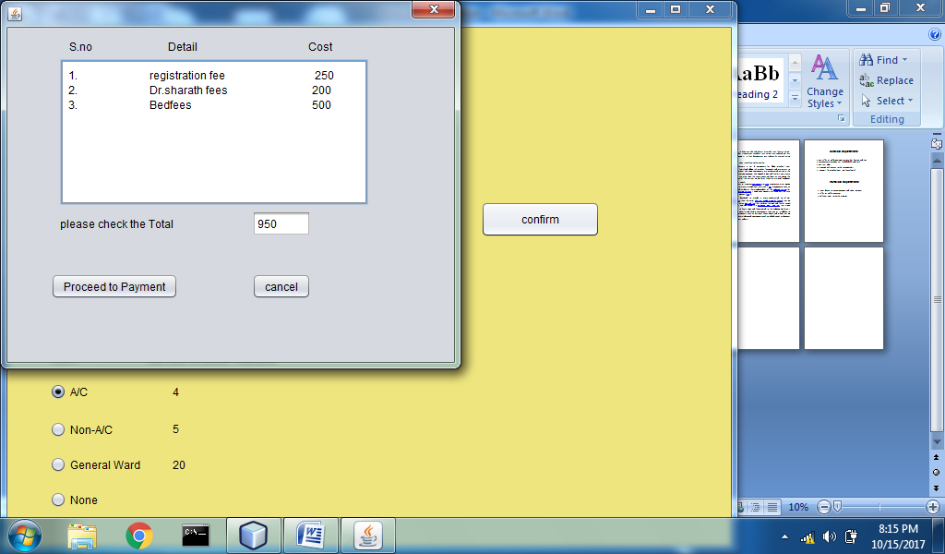

Figure 5

This window is the Final billing window where it displays the total bill according to the doctor and type of room chose in the previous window.

The registration fee is fixed for every patient.

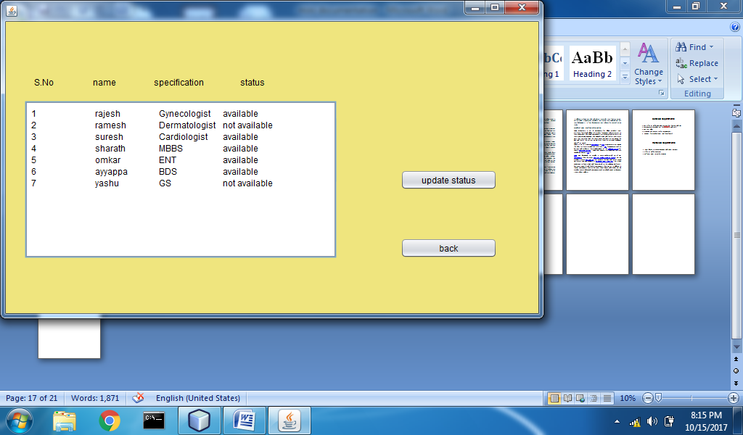

Figure 6

This window display various doctor details and their availability .This window contains a button to update the doctor status whether if they are available or not.

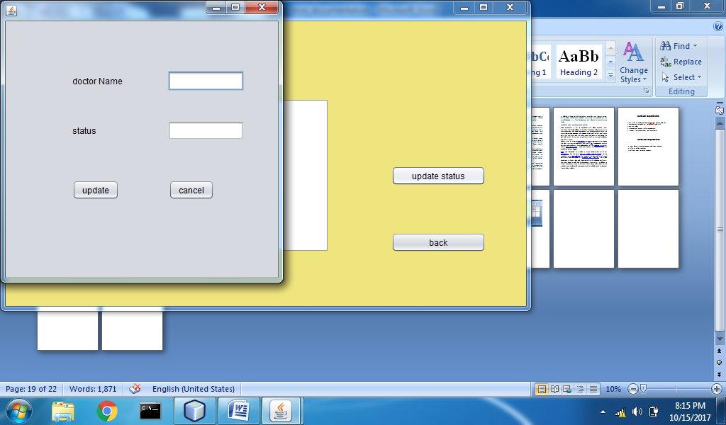

Figure 7

In this Figure we enter the doctor name whose status is to be updated.

**5. TESTING AND VALIDATION**

**5.1 Introduction**

Testing and validation of the program is a crucial part of project. It is impossible to determine all of the exceptional cases that might arise during the design of the program. Hence testing serves as a useful way to find the flaws in both the structure of the program and the implementation of the various functions.

**5.2 Design of Test Cases and Scenarios**

The test cases were designed keeping in mind where the program is liable to fail and throw errors or give erroneous outputs. The following cases are some of the important scenarios to be kept in mind.

**Alphabets and Symbols for Numeric Fields**

If any alphabets or symbols are entered for any numbers like Mobile Number ,Age the following message box pops up.

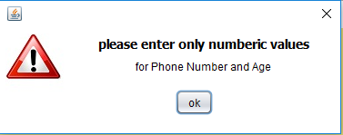

**Empty Fields**

If any fields are left empty the following message box is displayed.

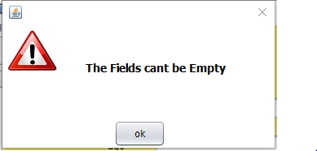

**Radio Button unchecked error:**

If any of the Radio Button is not selected this dialog box pops up.

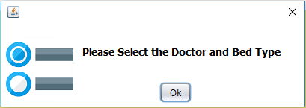

**Invalid Registration Number:**

If the registration number entered does contain characters other than integers then and also if patient is not found for the given registration number then it pops the following dialog box.

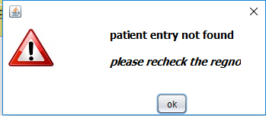

**Update Status error:**

If entered doctor name does not match with the doctors present the following dialog box pops up

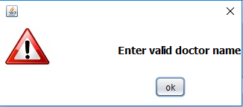

In the update status text field if words other than available or non available, the following dialog box pops up

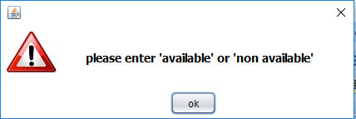

**5.3 Validation**

The program was validated by running a test case with some correct answers and some wrong answers, as well as both wrong and correct login credentials. Care was taken to include all possible exceptional cases and other problematic scenarios in the input.

**5.4 Conclusion**

After extensive testing and the final validation, it was concluded that the project is successful in carrying out all the functionalities mentioned throughout this report.

**6. REFERENCES**

1. http://docs.oracle.com/javase/tutorial/uiswing/
2. https://docs.oracle.com/javase/tutorial/essential/io/objectstreams.html
3. https://www.tutorialspoint.com/javaexamples/java_simple_gui.htm
4. https://netbeans.org/kb/docs/java/gui-functionality.html
5. https://www.tutorialspoint.com/java/ java_files_io.htm

**7. APPENDIX**

**PROGRAM**

package miniproject;

import java.awt.Color;

import java.io.FileInputStream;

import java.io.FileOutputStream;

import java.io.ObjectInputStream;

import java.io.ObjectOutputStream;

import java.io.Serializable;

import java.util.ArrayList;

import java.util.Iterator;

class Patient implements Serializable

{

public String name;

public long phno;

public int age;

public String date;

public String problem;

public String addr;

public String gender;

public int regno;

public String doctor;

public Patient()

{}

public Patient(String name,long phno,int age,String date,String problem,String addr,String gender,int regno)

{

this.name=name;

this.phno=phno;

this.age=age;

this.date=date;

this.problem=problem;

this.addr=addr;

this.gender=gender;

this.regno=regno;

}

public String toString(){

return "name"+name+" id no"+regno;

}

}

class Doctor

{

int dfees;

String name;

String status;

String spc;

Doctor(){}

Doctor(int f,String n,String s,String spc)

{

dfees=f;

name=n;

status=s;

this.spc=spc;

}

}

public class mainFrame extends javax.swing.JFrame {

/**

* Creates new form mainFrame

*/int id;

Patient pat[]=new Patient[30];

Doctor doc[]=new Doctor[10];

int docno=-1,bedfees=-1,totalbill=250;

public mainFrame() {

initComponents();

int i;

getContentPane().setBackground(new Color(239,229,126));

patient.getContentPane().setBackground(new Color(239,229,126));

patdet.getContentPane().setBackground(new Color(239,229,126));

patreg.getContentPane().setBackground(new Color(239,229,126));

doctor.getContentPane().setBackground(new Color(239,229,126));

statuserror.getContentPane().setBackground(Color.WHITE);

digiterror.getContentPane().setBackground(Color.WHITE);

stringerror.getContentPane().setBackground(Color.white);

negative.getContentPane().setBackground(Color.WHITE);

empty.getContentPane().setBackground(Color.WHITE);

checkboxerror.getContentPane().setBackground(Color.WHITE);

searchpat.getContentPane().setBackground(Color.WHITE);

searchdoc.getContentPane().setBackground(Color.WHITE);

BILLING.getContentPane().setBackground(new Color(239,229,126));

jTextArea1.append("1.\tregistration fee \t \t 250"+"\n");

for(i=0;i<30;i++)

{

pat[i]=new Patient();

}

doc[0]=new Doctor(200,"rajesh","available","Gynecologist");

doc[1]=new Doctor(200,"ramesh","not available","Dermatologist");

doc[2]=new Doctor(200,"suresh","available","Cardiologist");

doc[3]=new Doctor(200,"sharath","available","MBBS");

doc[4]=new Doctor(200,"omkar","available","ENT");

doc[5]=new Doctor(100,"ayyappa","available","BDS");

doc[6]=new Doctor(200,"yashu","not available","GS");

jTextField9.setEditable(false);

jTextArea1.setEditable(false);

jTextArea2.setEditable(false);

jTextArea3.setEditable(false);

jTextField13.setEditable(false);

jTextField12.setEditable(false);

jTextField14.setEditable(false);

jTextField15.setEditable(false);

jTextField16.setEditable(false);

jTextField17.setEditable(false);

jTextField18.setEditable(false);

jTextField19.setEditable(false);

jTextField20.setEditable(false);

ArrayList<Patient> list=new ArrayList<Patient>();

try{

ObjectInputStream ois1=new ObjectInputStream(new FileInputStream("patientdata"));

list=(ArrayList<Patient>)ois1.readObject();

}catch(Exception e){System.out.println(e);}

id=300+list.size();

}

/**

* This method is called from within the constructor to initialize the form.

* WARNING: Do NOT modify this code. The content of this method is always

* regenerated by the Form Editor.

*/

@SuppressWarnings("unchecked")

// <editor-fold defaultstate="collapsed" desc="Generated Code">

private void initComponents() {

patient = new javax.swing.JFrame();

jButton3 = new javax.swing.JButton();

jButton4 = new javax.swing.JButton();

jButton5 = new javax.swing.JButton();

jLabel2 = new javax.swing.JLabel();

patreg = new javax.swing.JFrame();

jLabel3 = new javax.swing.JLabel();

jLabel5 = new javax.swing.JLabel();

jLabel4 = new javax.swing.JLabel();

jLabel6 = new javax.swing.JLabel();

jLabel7 = new javax.swing.JLabel();

jLabel8 = new javax.swing.JLabel();

jLabel9 = new javax.swing.JLabel();

jLabel10 = new javax.swing.JLabel();

jTextField1 = new javax.swing.JTextField();

jTextField2 = new javax.swing.JTextField();

jTextField3 = new javax.swing.JTextField();

jTextField4 = new javax.swing.JTextField();

jTextField5 = new javax.swing.JTextField();

jTextField6 = new javax.swing.JTextField();

jTextField7 = new javax.swing.JTextField();

jButton6 = new javax.swing.JButton();

jButton7 = new javax.swing.JButton();

jTextField13 = new javax.swing.JTextField();

BILLING = new javax.swing.JFrame();

jLabel11 = new javax.swing.JLabel();

jRadioButton1 = new javax.swing.JRadioButton();

jRadioButton2 = new javax.swing.JRadioButton();

jRadioButton3 = new javax.swing.JRadioButton();

jLabel12 = new javax.swing.JLabel();

jRadioButton4 = new javax.swing.JRadioButton();

jLabel15 = new javax.swing.JLabel();

jRadioButton5 = new javax.swing.JRadioButton();

jRadioButton6 = new javax.swing.JRadioButton();

jRadioButton7 = new javax.swing.JRadioButton();

jRadioButton8 = new javax.swing.JRadioButton();

jButton9 = new javax.swing.JButton();

jLabel24 = new javax.swing.JLabel();

jRadioButton9 = new javax.swing.JRadioButton();

jRadioButton10 = new javax.swing.JRadioButton();

jRadioButton11 = new javax.swing.JRadioButton();

jLabel13 = new javax.swing.JLabel();

jLabel14 = new javax.swing.JLabel();

jLabel25 = new javax.swing.JLabel();

buttonGroup1 = new javax.swing.ButtonGroup();

buttonGroup2 = new javax.swing.ButtonGroup();

patdet = new javax.swing.JFrame();

jLabel20 = new javax.swing.JLabel();

jTextField10 = new javax.swing.JTextField();

jScrollBar1 = new javax.swing.JScrollBar();

jButton10 = new javax.swing.JButton();

jButton13 = new javax.swing.JButton();

jScrollPane2 = new javax.swing.JScrollPane();

jTextArea2 = new javax.swing.JTextArea();

jLabel26 = new javax.swing.JLabel();

jLabel27 = new javax.swing.JLabel();

jLabel29 = new javax.swing.JLabel();

jLabel59 = new javax.swing.JLabel();

doctor = new javax.swing.JFrame();

jLabel21 = new javax.swing.JLabel();

jLabel22 = new javax.swing.JLabel();

jLabel23 = new javax.swing.JLabel();

jButton11 = new javax.swing.JButton();

jButton12 = new javax.swing.JButton();

jScrollPane3 = new javax.swing.JScrollPane();

jTextArea3 = new javax.swing.JTextArea();

jLabel46 = new javax.swing.JLabel();

update = new javax.swing.JFrame();

jLabel30 = new javax.swing.JLabel();

jTextField8 = new javax.swing.JTextField();

jLabel31 = new javax.swing.JLabel();

jTextField11 = new javax.swing.JTextField();

jButton8 = new javax.swing.JButton();

jButton14 = new javax.swing.JButton();

paydia = new javax.swing.JDialog();

jLabel32 = new javax.swing.JLabel();

jButton15 = new javax.swing.JButton();

jButton16 = new javax.swing.JButton();

jScrollPane1 = new javax.swing.JScrollPane();

jTextArea1 = new javax.swing.JTextArea();

jTextField9 = new javax.swing.JTextField();

jLabel16 = new javax.swing.JLabel();

jLabel17 = new javax.swing.JLabel();

jLabel18 = new javax.swing.JLabel();

jDialog1 = new javax.swing.JDialog();

jLabel19 = new javax.swing.JLabel();

jLabel33 = new javax.swing.JLabel();

jLabel34 = new javax.swing.JLabel();

jLabel35 = new javax.swing.JLabel();

jLabel36 = new javax.swing.JLabel();

jLabel37 = new javax.swing.JLabel();

jLabel38 = new javax.swing.JLabel();

jButton17 = new javax.swing.JButton();

jTextField12 = new javax.swing.JTextField();

jLabel39 = new javax.swing.JLabel();

jTextField14 = new javax.swing.JTextField();

jTextField15 = new javax.swing.JTextField();

jTextField16 = new javax.swing.JTextField();

jTextField17 = new javax.swing.JTextField();

jTextField18 = new javax.swing.JTextField();

jTextField19 = new javax.swing.JTextField();

jTextField20 = new javax.swing.JTextField();

empty = new javax.swing.JDialog();

jLabel40 = new javax.swing.JLabel();

jButton18 = new javax.swing.JButton();

jLabel48 = new javax.swing.JLabel();

negative = new javax.swing.JDialog();

jButton19 = new javax.swing.JButton();

jLabel41 = new javax.swing.JLabel();

stringerror = new javax.swing.JDialog();

jLabel42 = new javax.swing.JLabel();

jButton20 = new javax.swing.JButton();

jLabel28 = new javax.swing.JLabel();

jLabel49 = new javax.swing.JLabel();

searchdoc = new javax.swing.JDialog();

jLabel43 = new javax.swing.JLabel();

jButton21 = new javax.swing.JButton();

jLabel54 = new javax.swing.JLabel();

searchpat = new javax.swing.JDialog();

jLabel44 = new javax.swing.JLabel();

jButton22 = new javax.swing.JButton();

jLabel52 = new javax.swing.JLabel();

jLabel53 = new javax.swing.JLabel();

statuserror = new javax.swing.JDialog();

jButton23 = new javax.swing.JButton();

jLabel45 = new javax.swing.JLabel();

jLabel55 = new javax.swing.JLabel();

digiterror = new javax.swing.JDialog();

jLabel47 = new javax.swing.JLabel();

jButton24 = new javax.swing.JButton();

jLabel56 = new javax.swing.JLabel();

checkboxerror = new javax.swing.JDialog();

jLabel50 = new javax.swing.JLabel();

jLabel51 = new javax.swing.JLabel();

jButton25 = new javax.swing.JButton();

bederror = new javax.swing.JDialog();

jLabel57 = new javax.swing.JLabel();

jLabel58 = new javax.swing.JLabel();

jButton26 = new javax.swing.JButton();

jLabel1 = new javax.swing.JLabel();

jButton1 = new javax.swing.JButton();

jButton2 = new javax.swing.JButton();

jButton3.setText("patient registration");

jButton3.addActionListener(new java.awt.event.ActionListener() {

public void actionPerformed(java.awt.event.ActionEvent evt) {

jButton3ActionPerformed(evt);

}

});

jButton4.setText("patient details");

jButton4.addActionListener(new java.awt.event.ActionListener() {

public void actionPerformed(java.awt.event.ActionEvent evt) {

jButton4ActionPerformed(evt);

}

});

jButton5.setText("Back");

jButton5.addActionListener(new java.awt.event.ActionListener() {

public void actionPerformed(java.awt.event.ActionEvent evt) {

jButton5ActionPerformed(evt);

}

});

jLabel2.setIcon(new javax.swing.ImageIcon(getClass().getResource("/miniproject/patient.jpg"))); // NOI18N

javax.swing.GroupLayout patientLayout = new javax.swing.GroupLayout(patient.getContentPane());

patient.getContentPane().setLayout(patientLayout);

patientLayout.setHorizontalGroup(

patientLayout.createParallelGroup(javax.swing.GroupLayout.Alignment.LEADING)

.addGroup(javax.swing.GroupLayout.Alignment.TRAILING, patientLayout.createSequentialGroup()

.addGap(65, 65, 65)

.addComponent(jLabel2)

.addPreferredGap(javax.swing.LayoutStyle.ComponentPlacement.RELATED, 57, Short.MAX_VALUE)

.addGroup(patientLayout.createParallelGroup(javax.swing.GroupLayout.Alignment.LEADING)

.addGroup(javax.swing.GroupLayout.Alignment.TRAILING, patientLayout.createSequentialGroup()

.addGroup(patientLayout.createParallelGroup(javax.swing.GroupLayout.Alignment.LEADING)

.addComponent(jButton4, javax.swing.GroupLayout.PREFERRED_SIZE, 233, javax.swing.GroupLayout.PREFERRED_SIZE)

.addComponent(jButton3, javax.swing.GroupLayout.PREFERRED_SIZE, 233, javax.swing.GroupLayout.PREFERRED_SIZE))

.addGap(45, 45, 45))

.addGroup(javax.swing.GroupLayout.Alignment.TRAILING, patientLayout.createSequentialGroup()

.addComponent(jButton5)

.addGap(139, 139, 139))))

);

patientLayout.setVerticalGroup(

patientLayout.createParallelGroup(javax.swing.GroupLayout.Alignment.LEADING)

.addGroup(patientLayout.createSequentialGroup()

.addGroup(patientLayout.createParallelGroup(javax.swing.GroupLayout.Alignment.LEADING)

.addGroup(patientLayout.createSequentialGroup()

.addGap(88, 88, 88)

.addComponent(jLabel2))

.addGroup(patientLayout.createSequentialGroup()

.addGap(137, 137, 137)

.addComponent(jButton3, javax.swing.GroupLayout.PREFERRED_SIZE, 46, javax.swing.GroupLayout.PREFERRED_SIZE)

.addGap(28, 28, 28)

.addComponent(jButton4, javax.swing.GroupLayout.PREFERRED_SIZE, 48, javax.swing.GroupLayout.PREFERRED_SIZE)

.addGap(30, 30, 30)

.addComponent(jButton5)))

.addContainerGap(115, Short.MAX_VALUE))

);

jLabel3.setText("Name");

jLabel5.setText("age");

jLabel4.setText("gender(M/F)");

jLabel6.setText("patiend id:");

jLabel7.setText("address");

jLabel8.setText("date addmitted");

jLabel9.setText("mobile no");

jLabel10.setText("problem");

jTextField1.addActionListener(new java.awt.event.ActionListener() {

public void actionPerformed(java.awt.event.ActionEvent evt) {

jTextField1ActionPerformed(evt);

}

});

jTextField3.addActionListener(new java.awt.event.ActionListener() {

public void actionPerformed(java.awt.event.ActionEvent evt) {

jTextField3ActionPerformed(evt);

}

});

jButton6.setText("confirm to billing");

jButton6.addActionListener(new java.awt.event.ActionListener() {

public void actionPerformed(java.awt.event.ActionEvent evt) {

jButton6ActionPerformed(evt);

}

});

jButton7.setText("back");

jButton7.addActionListener(new java.awt.event.ActionListener() {

public void actionPerformed(java.awt.event.ActionEvent evt) {

jButton7ActionPerformed(evt);

}

});

javax.swing.GroupLayout patregLayout = new javax.swing.GroupLayout(patreg.getContentPane());

patreg.getContentPane().setLayout(patregLayout);

patregLayout.setHorizontalGroup(

patregLayout.createParallelGroup(javax.swing.GroupLayout.Alignment.LEADING)

.addGroup(patregLayout.createSequentialGroup()

.addGap(24, 24, 24)

.addComponent(jLabel6)

.addGap(18, 18, 18)

.addComponent(jTextField13, javax.swing.GroupLayout.PREFERRED_SIZE, 65, javax.swing.GroupLayout.PREFERRED_SIZE)

.addContainerGap(javax.swing.GroupLayout.DEFAULT_SIZE, Short.MAX_VALUE))

.addGroup(patregLayout.createSequentialGroup()

.addGap(68, 68, 68)

.addGroup(patregLayout.createParallelGroup(javax.swing.GroupLayout.Alignment.TRAILING)

.addComponent(jLabel9)

.addComponent(jLabel7)

.addComponent(jLabel8)

.addComponent(jLabel4)

.addComponent(jLabel5)

.addComponent(jLabel3)

.addComponent(jLabel10))

.addGap(37, 37, 37)

.addGroup(patregLayout.createParallelGroup(javax.swing.GroupLayout.Alignment.TRAILING, false)

.addComponent(jTextField5, javax.swing.GroupLayout.Alignment.LEADING, javax.swing.GroupLayout.DEFAULT_SIZE, 172, Short.MAX_VALUE)

.addComponent(jTextField4, javax.swing.GroupLayout.Alignment.LEADING, javax.swing.GroupLayout.PREFERRED_SIZE, javax.swing.GroupLayout.DEFAULT_SIZE, javax.swing.GroupLayout.PREFERRED_SIZE)

.addComponent(jTextField3, javax.swing.GroupLayout.Alignment.LEADING, javax.swing.GroupLayout.PREFERRED_SIZE, javax.swing.GroupLayout.DEFAULT_SIZE, javax.swing.GroupLayout.PREFERRED_SIZE)

.addComponent(jTextField2, javax.swing.GroupLayout.Alignment.LEADING, javax.swing.GroupLayout.PREFERRED_SIZE, javax.swing.GroupLayout.DEFAULT_SIZE, javax.swing.GroupLayout.PREFERRED_SIZE)

.addComponent(jTextField6, javax.swing.GroupLayout.Alignment.LEADING, javax.swing.GroupLayout.PREFERRED_SIZE, javax.swing.GroupLayout.DEFAULT_SIZE, javax.swing.GroupLayout.PREFERRED_SIZE)

.addComponent(jTextField7, javax.swing.GroupLayout.Alignment.LEADING, javax.swing.GroupLayout.PREFERRED_SIZE, javax.swing.GroupLayout.DEFAULT_SIZE, javax.swing.GroupLayout.PREFERRED_SIZE)

.addComponent(jTextField1, javax.swing.GroupLayout.Alignment.LEADING))

.addPreferredGap(javax.swing.LayoutStyle.ComponentPlacement.RELATED, 166, Short.MAX_VALUE)

.addGroup(patregLayout.createParallelGroup(javax.swing.GroupLayout.Alignment.LEADING)

.addComponent(jButton6)

.addComponent(jButton7))

.addGap(121, 121, 121))

);

patregLayout.linkSize(javax.swing.SwingConstants.HORIZONTAL, new java.awt.Component[] {jTextField1, jTextField2, jTextField3, jTextField4, jTextField5, jTextField6, jTextField7});

patregLayout.setVerticalGroup(

patregLayout.createParallelGroup(javax.swing.GroupLayout.Alignment.LEADING)

.addGroup(patregLayout.createSequentialGroup()

.addGap(21, 21, 21)

.addGroup(patregLayout.createParallelGroup(javax.swing.GroupLayout.Alignment.BASELINE)

.addComponent(jLabel6, javax.swing.GroupLayout.PREFERRED_SIZE, 16, javax.swing.GroupLayout.PREFERRED_SIZE)

.addComponent(jTextField13, javax.swing.GroupLayout.PREFERRED_SIZE, javax.swing.GroupLayout.DEFAULT_SIZE, javax.swing.GroupLayout.PREFERRED_SIZE))

.addGap(39, 39, 39)

.addGroup(patregLayout.createParallelGroup(javax.swing.GroupLayout.Alignment.LEADING)

.addComponent(jTextField1, javax.swing.GroupLayout.Alignment.TRAILING, javax.swing.GroupLayout.PREFERRED_SIZE, javax.swing.GroupLayout.DEFAULT_SIZE, javax.swing.GroupLayout.PREFERRED_SIZE)

.addComponent(jLabel3))

.addGap(18, 18, 18)

.addGroup(patregLayout.createParallelGroup(javax.swing.GroupLayout.Alignment.BASELINE)

.addComponent(jLabel5)

.addComponent(jTextField2, javax.swing.GroupLayout.PREFERRED_SIZE, javax.swing.GroupLayout.DEFAULT_SIZE, javax.swing.GroupLayout.PREFERRED_SIZE))

.addGap(18, 18, 18)

.addGroup(patregLayout.createParallelGroup(javax.swing.GroupLayout.Alignment.BASELINE)

.addComponent(jLabel4)

.addComponent(jTextField3, javax.swing.GroupLayout.PREFERRED_SIZE, javax.swing.GroupLayout.DEFAULT_SIZE, javax.swing.GroupLayout.PREFERRED_SIZE)

.addComponent(jButton6))

.addGap(21, 21, 21)

.addGroup(patregLayout.createParallelGroup(javax.swing.GroupLayout.Alignment.BASELINE)

.addComponent(jLabel8)

.addComponent(jTextField4, javax.swing.GroupLayout.PREFERRED_SIZE, javax.swing.GroupLayout.DEFAULT_SIZE, javax.swing.GroupLayout.PREFERRED_SIZE))

.addGroup(patregLayout.createParallelGroup(javax.swing.GroupLayout.Alignment.LEADING)

.addGroup(patregLayout.createSequentialGroup()

.addGap(18, 18, 18)

.addGroup(patregLayout.createParallelGroup(javax.swing.GroupLayout.Alignment.BASELINE)

.addComponent(jLabel7, javax.swing.GroupLayout.PREFERRED_SIZE, 31, javax.swing.GroupLayout.PREFERRED_SIZE)

.addComponent(jTextField5, javax.swing.GroupLayout.PREFERRED_SIZE, 77, javax.swing.GroupLayout.PREFERRED_SIZE)))

.addGroup(patregLayout.createSequentialGroup()

.addGap(30, 30, 30)

.addComponent(jButton7)))

.addGap(18, 18, 18)

.addGroup(patregLayout.createParallelGroup(javax.swing.GroupLayout.Alignment.LEADING)

.addComponent(jTextField6, javax.swing.GroupLayout.PREFERRED_SIZE, javax.swing.GroupLayout.DEFAULT_SIZE, javax.swing.GroupLayout.PREFERRED_SIZE)

.addComponent(jLabel9))

.addGap(19, 19, 19)

.addGroup(patregLayout.createParallelGroup(javax.swing.GroupLayout.Alignment.BASELINE)

.addComponent(jLabel10)

.addComponent(jTextField7, javax.swing.GroupLayout.PREFERRED_SIZE, javax.swing.GroupLayout.DEFAULT_SIZE, javax.swing.GroupLayout.PREFERRED_SIZE))

.addContainerGap(57, Short.MAX_VALUE))

);

jLabel11.setText("room");

buttonGroup2.add(jRadioButton1);

jRadioButton1.setText("A/C ");

jRadioButton1.addActionListener(new java.awt.event.ActionListener() {

public void actionPerformed(java.awt.event.ActionEvent evt) {

jRadioButton1ActionPerformed(evt);

}

});

buttonGroup2.add(jRadioButton2);

jRadioButton2.setText("Non-A/C");

jRadioButton2.addActionListener(new java.awt.event.ActionListener() {

public void actionPerformed(java.awt.event.ActionEvent evt) {

jRadioButton2ActionPerformed(evt);

}

});

buttonGroup2.add(jRadioButton3);

jRadioButton3.setText("General Ward");

jRadioButton3.addActionListener(new java.awt.event.ActionListener() {

public void actionPerformed(java.awt.event.ActionEvent evt) {

jRadioButton3ActionPerformed(evt);

}

});

buttonGroup2.add(jRadioButton4);

jRadioButton4.setText("None");

jRadioButton4.addActionListener(new java.awt.event.ActionListener() {

public void actionPerformed(java.awt.event.ActionEvent evt) {

jRadioButton4ActionPerformed(evt);

}

});

jLabel15.setText("doctor");

buttonGroup1.add(jRadioButton5);

jRadioButton5.setText("rajesh");

jRadioButton5.addActionListener(new java.awt.event.ActionListener() {

public void actionPerformed(java.awt.event.ActionEvent evt) {

jRadioButton5ActionPerformed(evt);

}

});

buttonGroup1.add(jRadioButton6);

jRadioButton6.setText("ramesh");

jRadioButton6.addActionListener(new java.awt.event.ActionListener() {

public void actionPerformed(java.awt.event.ActionEvent evt) {

jRadioButton6ActionPerformed(evt);

}

});

buttonGroup1.add(jRadioButton7);

jRadioButton7.setText("suresh");

jRadioButton7.addActionListener(new java.awt.event.ActionListener() {

public void actionPerformed(java.awt.event.ActionEvent evt) {

jRadioButton7ActionPerformed(evt);

}

});

buttonGroup1.add(jRadioButton8);

jRadioButton8.setText("sharath");

jRadioButton8.addActionListener(new java.awt.event.ActionListener() {

public void actionPerformed(java.awt.event.ActionEvent evt) {

jRadioButton8ActionPerformed(evt);

}

});

jButton9.setText("confirm");

jButton9.addActionListener(new java.awt.event.ActionListener() {

public void actionPerformed(java.awt.event.ActionEvent evt) {

jButton9ActionPerformed(evt);

}

});

jLabel24.setText("Number of Beds Available");

buttonGroup1.add(jRadioButton9);

jRadioButton9.setText("omkar");

jRadioButton9.addActionListener(new java.awt.event.ActionListener() {

public void actionPerformed(java.awt.event.ActionEvent evt) {

jRadioButton9ActionPerformed(evt);

}

});

buttonGroup1.add(jRadioButton10);

jRadioButton10.setText("ayyappa");

jRadioButton10.addActionListener(new java.awt.event.ActionListener() {

public void actionPerformed(java.awt.event.ActionEvent evt) {

jRadioButton10ActionPerformed(evt);

}

});

buttonGroup1.add(jRadioButton11);

jRadioButton11.setText("yashwanth");

jRadioButton11.addActionListener(new java.awt.event.ActionListener() {

public void actionPerformed(java.awt.event.ActionEvent evt) {

jRadioButton11ActionPerformed(evt);

}

});

jLabel13.setText("jLabel13");

jLabel14.setText("jLabel14");

jLabel25.setText("jLabel25");

javax.swing.GroupLayout BILLINGLayout = new javax.swing.GroupLayout(BILLING.getContentPane());

BILLING.getContentPane().setLayout(BILLINGLayout);

BILLINGLayout.setHorizontalGroup(

BILLINGLayout.createParallelGroup(javax.swing.GroupLayout.Alignment.LEADING)

.addGroup(BILLINGLayout.createSequentialGroup()

.addGap(46, 46, 46)

.addGroup(BILLINGLayout.createParallelGroup(javax.swing.GroupLayout.Alignment.LEADING)

.addGroup(BILLINGLayout.createSequentialGroup()

.addGroup(BILLINGLayout.createParallelGroup(javax.swing.GroupLayout.Alignment.LEADING)

.addComponent(jLabel15)

.addComponent(jRadioButton9)

.addGroup(BILLINGLayout.createSequentialGroup()

.addGroup(BILLINGLayout.createParallelGroup(javax.swing.GroupLayout.Alignment.LEADING)

.addGroup(BILLINGLayout.createParallelGroup(javax.swing.GroupLayout.Alignment.LEADING)

.addGroup(javax.swing.GroupLayout.Alignment.TRAILING, BILLINGLayout.createSequentialGroup()

.addComponent(jRadioButton6)

.addGap(51, 51, 51))

.addGroup(BILLINGLayout.createSequentialGroup()

.addComponent(jRadioButton5)

.addGap(57, 57, 57)))

.addGroup(BILLINGLayout.createSequentialGroup()

.addComponent(jRadioButton7)

.addGap(55, 55, 55)))

.addGroup(BILLINGLayout.createParallelGroup(javax.swing.GroupLayout.Alignment.LEADING)

.addComponent(jRadioButton11)

.addComponent(jRadioButton8)

.addComponent(jRadioButton10))))

.addContainerGap(533, Short.MAX_VALUE))

.addGroup(BILLINGLayout.createSequentialGroup()

.addGroup(BILLINGLayout.createParallelGroup(javax.swing.GroupLayout.Alignment.LEADING)

.addComponent(jLabel11)

.addGroup(BILLINGLayout.createSequentialGroup()

.addGroup(BILLINGLayout.createParallelGroup(javax.swing.GroupLayout.Alignment.LEADING)

.addComponent(jRadioButton3)

.addComponent(jRadioButton1)

.addComponent(jRadioButton4)

.addComponent(jRadioButton2))

.addGroup(BILLINGLayout.createParallelGroup(javax.swing.GroupLayout.Alignment.LEADING)

.addGroup(javax.swing.GroupLayout.Alignment.TRAILING, BILLINGLayout.createSequentialGroup()

.addPreferredGap(javax.swing.LayoutStyle.ComponentPlacement.RELATED)

.addComponent(jLabel24))

.addGroup(BILLINGLayout.createSequentialGroup()

.addGap(35, 35, 35)

.addGroup(BILLINGLayout.createParallelGroup(javax.swing.GroupLayout.Alignment.LEADING)

.addComponent(jLabel13)

.addGroup(BILLINGLayout.createParallelGroup(javax.swing.GroupLayout.Alignment.TRAILING)

.addGroup(BILLINGLayout.createSequentialGroup()

.addComponent(jLabel12)

.addGap(50, 50, 50))

.addComponent(jLabel14, javax.swing.GroupLayout.Alignment.LEADING)

.addComponent(jLabel25, javax.swing.GroupLayout.Alignment.LEADING)))))))

.addPreferredGap(javax.swing.LayoutStyle.ComponentPlacement.RELATED, javax.swing.GroupLayout.DEFAULT_SIZE, Short.MAX_VALUE)

.addComponent(jButton9, javax.swing.GroupLayout.PREFERRED_SIZE, 129, javax.swing.GroupLayout.PREFERRED_SIZE)

.addGap(142, 142, 142))))

);

BILLINGLayout.setVerticalGroup(

BILLINGLayout.createParallelGroup(javax.swing.GroupLayout.Alignment.LEADING)

.addGroup(javax.swing.GroupLayout.Alignment.TRAILING, BILLINGLayout.createSequentialGroup()

.addGap(21, 21, 21)

.addComponent(jLabel15)

.addGap(18, 18, 18)

.addGroup(BILLINGLayout.createParallelGroup(javax.swing.GroupLayout.Alignment.BASELINE)

.addComponent(jRadioButton5)

.addComponent(jRadioButton8))

.addGap(20, 20, 20)

.addGroup(BILLINGLayout.createParallelGroup(javax.swing.GroupLayout.Alignment.BASELINE)

.addComponent(jRadioButton6)

.addComponent(jRadioButton10))

.addGap(20, 20, 20)

.addGroup(BILLINGLayout.createParallelGroup(javax.swing.GroupLayout.Alignment.BASELINE)

.addComponent(jRadioButton7)

.addComponent(jRadioButton11))

.addGap(20, 20, 20)

.addComponent(jRadioButton9)

.addGroup(BILLINGLayout.createParallelGroup(javax.swing.GroupLayout.Alignment.LEADING)

.addGroup(BILLINGLayout.createSequentialGroup()

.addPreferredGap(javax.swing.LayoutStyle.ComponentPlacement.RELATED, 34, Short.MAX_VALUE)

.addGroup(BILLINGLayout.createParallelGroup(javax.swing.GroupLayout.Alignment.LEADING)

.addGroup(BILLINGLayout.createSequentialGroup()

.addGap(57, 57, 57)

.addComponent(jLabel12))

.addGroup(BILLINGLayout.createSequentialGroup()

.addGroup(BILLINGLayout.createParallelGroup(javax.swing.GroupLayout.Alignment.BASELINE)

.addComponent(jLabel11)

.addComponent(jLabel24))

.addGap(20, 20, 20)

.addGroup(BILLINGLayout.createParallelGroup(javax.swing.GroupLayout.Alignment.BASELINE)

.addComponent(jRadioButton1)

.addComponent(jLabel13))))

.addGap(20, 20, 20))

.addGroup(BILLINGLayout.createSequentialGroup()

.addGap(1, 1, 1)

.addComponent(jButton9, javax.swing.GroupLayout.PREFERRED_SIZE, 39, javax.swing.GroupLayout.PREFERRED_SIZE)

.addPreferredGap(javax.swing.LayoutStyle.ComponentPlacement.RELATED, javax.swing.GroupLayout.DEFAULT_SIZE, Short.MAX_VALUE)))

.addGroup(BILLINGLayout.createParallelGroup(javax.swing.GroupLayout.Alignment.LEADING)

.addComponent(jLabel14)

.addComponent(jRadioButton2))

.addGap(20, 20, 20)

.addGroup(BILLINGLayout.createParallelGroup(javax.swing.GroupLayout.Alignment.BASELINE)

.addComponent(jRadioButton3)

.addComponent(jLabel25))

.addGap(20, 20, 20)

.addComponent(jRadioButton4)

.addGap(42, 42, 42))

);

jLabel20.setText("registration Number");

jTextField10.addActionListener(new java.awt.event.ActionListener() {

public void actionPerformed(java.awt.event.ActionEvent evt) {

jTextField10ActionPerformed(evt);

}

});

jButton10.setText("search");

jButton10.addActionListener(new java.awt.event.ActionListener() {

public void actionPerformed(java.awt.event.ActionEvent evt) {

jButton10ActionPerformed(evt);

}

});

jButton13.setText("back");

jButton13.addActionListener(new java.awt.event.ActionListener() {

public void actionPerformed(java.awt.event.ActionEvent evt) {

jButton13ActionPerformed(evt);

}

});

jTextArea2.setColumns(20);

jTextArea2.setRows(5);

jScrollPane2.setViewportView(jTextArea2);

jLabel26.setText("S.no");

jLabel26.setBorder(javax.swing.BorderFactory.createBevelBorder(javax.swing.border.BevelBorder.RAISED));

jLabel27.setText("Name");

jLabel27.setBorder(javax.swing.BorderFactory.createBevelBorder(javax.swing.border.BevelBorder.RAISED));

jLabel29.setText("DOA");

jLabel29.setBorder(javax.swing.BorderFactory.createBevelBorder(javax.swing.border.BevelBorder.RAISED));

jLabel59.setText("regno");

jLabel59.setBorder(javax.swing.BorderFactory.createBevelBorder(javax.swing.border.BevelBorder.RAISED));

javax.swing.GroupLayout patdetLayout = new javax.swing.GroupLayout(patdet.getContentPane());

patdet.getContentPane().setLayout(patdetLayout);

patdetLayout.setHorizontalGroup(

patdetLayout.createParallelGroup(javax.swing.GroupLayout.Alignment.LEADING)

.addGroup(patdetLayout.createSequentialGroup()

.addGap(55, 55, 55)

.addGroup(patdetLayout.createParallelGroup(javax.swing.GroupLayout.Alignment.LEADING)

.addGroup(patdetLayout.createSequentialGroup()

.addComponent(jScrollPane2, javax.swing.GroupLayout.PREFERRED_SIZE, 628, javax.swing.GroupLayout.PREFERRED_SIZE)

.addGap(18, 18, 18)

.addComponent(jScrollBar1, javax.swing.GroupLayout.PREFERRED_SIZE, javax.swing.GroupLayout.DEFAULT_SIZE, javax.swing.GroupLayout.PREFERRED_SIZE)

.addContainerGap(21, Short.MAX_VALUE))

.addGroup(patdetLayout.createSequentialGroup()

.addComponent(jLabel20)

.addGap(63, 63, 63)

.addComponent(jTextField10, javax.swing.GroupLayout.PREFERRED_SIZE, 97, javax.swing.GroupLayout.PREFERRED_SIZE)

.addPreferredGap(javax.swing.LayoutStyle.ComponentPlacement.RELATED, javax.swing.GroupLayout.DEFAULT_SIZE, Short.MAX_VALUE)

.addComponent(jButton10)

.addGap(71, 71, 71)

.addComponent(jButton13)

.addGap(48, 48, 48))

.addGroup(patdetLayout.createSequentialGroup()

.addGap(11, 11, 11)

.addComponent(jLabel26)

.addGap(72, 72, 72)

.addComponent(jLabel59)

.addGap(107, 107, 107)

.addComponent(jLabel27)

.addPreferredGap(javax.swing.LayoutStyle.ComponentPlacement.RELATED, javax.swing.GroupLayout.DEFAULT_SIZE, Short.MAX_VALUE)

.addComponent(jLabel29)

.addGap(125, 125, 125))))

);

patdetLayout.setVerticalGroup(

patdetLayout.createParallelGroup(javax.swing.GroupLayout.Alignment.LEADING)

.addGroup(patdetLayout.createSequentialGroup()

.addGap(52, 52, 52)

.addGroup(patdetLayout.createParallelGroup(javax.swing.GroupLayout.Alignment.BASELINE)

.addComponent(jLabel20)

.addComponent(jTextField10, javax.swing.GroupLayout.PREFERRED_SIZE, javax.swing.GroupLayout.DEFAULT_SIZE, javax.swing.GroupLayout.PREFERRED_SIZE)

.addComponent(jButton10)

.addComponent(jButton13))

.addGap(69, 69, 69)

.addGroup(patdetLayout.createParallelGroup(javax.swing.GroupLayout.Alignment.BASELINE)

.addComponent(jLabel26)

.addComponent(jLabel27)

.addComponent(jLabel29)

.addComponent(jLabel59))

.addGap(20, 20, 20)

.addGroup(patdetLayout.createParallelGroup(javax.swing.GroupLayout.Alignment.LEADING, false)

.addComponent(jScrollBar1, javax.swing.GroupLayout.DEFAULT_SIZE, javax.swing.GroupLayout.DEFAULT_SIZE, Short.MAX_VALUE)

.addComponent(jScrollPane2, javax.swing.GroupLayout.DEFAULT_SIZE, 214, Short.MAX_VALUE))

.addContainerGap(105, Short.MAX_VALUE))

);

jLabel21.setFont(new java.awt.Font("Tahoma", 1, 11)); // NOI18N

jLabel21.setText("name");

jLabel21.setBorder(javax.swing.BorderFactory.createBevelBorder(javax.swing.border.BevelBorder.RAISED));

jLabel22.setFont(new java.awt.Font("Tahoma", 1, 11)); // NOI18N

jLabel22.setText("specification");

jLabel22.setBorder(javax.swing.BorderFactory.createBevelBorder(javax.swing.border.BevelBorder.RAISED));

jLabel23.setFont(new java.awt.Font("Tahoma", 1, 11)); // NOI18N

jLabel23.setText("status");

jLabel23.setBorder(javax.swing.BorderFactory.createBevelBorder(javax.swing.border.BevelBorder.RAISED));

jButton11.setText("back");

jButton11.addActionListener(new java.awt.event.ActionListener() {

public void actionPerformed(java.awt.event.ActionEvent evt) {

jButton11ActionPerformed(evt);

}

});

jButton12.setText("update status");

jButton12.addActionListener(new java.awt.event.ActionListener() {

public void actionPerformed(java.awt.event.ActionEvent evt) {

jButton12ActionPerformed(evt);

}

});

jTextArea3.setColumns(20);

jTextArea3.setRows(5);

jScrollPane3.setViewportView(jTextArea3);

jLabel46.setFont(new java.awt.Font("Tahoma", 1, 11)); // NOI18N

jLabel46.setText("S.No");

jLabel46.setBorder(javax.swing.BorderFactory.createBevelBorder(javax.swing.border.BevelBorder.RAISED));

javax.swing.GroupLayout doctorLayout = new javax.swing.GroupLayout(doctor.getContentPane());

doctor.getContentPane().setLayout(doctorLayout);

doctorLayout.setHorizontalGroup(

doctorLayout.createParallelGroup(javax.swing.GroupLayout.Alignment.LEADING)

.addGroup(doctorLayout.createSequentialGroup()

.addGroup(doctorLayout.createParallelGroup(javax.swing.GroupLayout.Alignment.LEADING)

.addGroup(doctorLayout.createSequentialGroup()

.addGap(39, 39, 39)

.addComponent(jLabel46)

.addGap(54, 54, 54)

.addComponent(jLabel21)

.addGap(52, 52, 52)

.addComponent(jLabel22)

.addGap(52, 52, 52)

.addComponent(jLabel23))

.addGroup(doctorLayout.createSequentialGroup()

.addGap(26, 26, 26)

.addComponent(jScrollPane3, javax.swing.GroupLayout.PREFERRED_SIZE, 422, javax.swing.GroupLayout.PREFERRED_SIZE)

.addGap(73, 73, 73)

.addGroup(doctorLayout.createParallelGroup(javax.swing.GroupLayout.Alignment.LEADING)

.addComponent(jButton12, javax.swing.GroupLayout.PREFERRED_SIZE, 133, javax.swing.GroupLayout.PREFERRED_SIZE)

.addComponent(jButton11, javax.swing.GroupLayout.PREFERRED_SIZE, 133, javax.swing.GroupLayout.PREFERRED_SIZE))))

.addContainerGap(21, Short.MAX_VALUE))

);

doctorLayout.setVerticalGroup(

doctorLayout.createParallelGroup(javax.swing.GroupLayout.Alignment.LEADING)

.addGroup(doctorLayout.createSequentialGroup()

.addGroup(doctorLayout.createParallelGroup(javax.swing.GroupLayout.Alignment.LEADING)

.addGroup(doctorLayout.createSequentialGroup()

.addGap(75, 75, 75)

.addGroup(doctorLayout.createParallelGroup(javax.swing.GroupLayout.Alignment.BASELINE)

.addComponent(jLabel21)

.addComponent(jLabel22)

.addComponent(jLabel46)))

.addGroup(javax.swing.GroupLayout.Alignment.TRAILING, doctorLayout.createSequentialGroup()

.addContainerGap()

.addComponent(jLabel23)))

.addGroup(doctorLayout.createParallelGroup(javax.swing.GroupLayout.Alignment.LEADING)

.addGroup(doctorLayout.createSequentialGroup()

.addGap(18, 18, 18)

.addComponent(jScrollPane3, javax.swing.GroupLayout.PREFERRED_SIZE, 200, javax.swing.GroupLayout.PREFERRED_SIZE))

.addGroup(doctorLayout.createSequentialGroup()

.addGap(49, 49, 49)

.addComponent(jButton12)

.addGap(65, 65, 65)

.addComponent(jButton11)))

.addContainerGap(javax.swing.GroupLayout.DEFAULT_SIZE, Short.MAX_VALUE))

);

jLabel30.setText("doctor Name");

jTextField8.addActionListener(new java.awt.event.ActionListener() {

public void actionPerformed(java.awt.event.ActionEvent evt) {

jTextField8ActionPerformed(evt);

}

});

jLabel31.setText("status");

jTextField11.addActionListener(new java.awt.event.ActionListener() {

public void actionPerformed(java.awt.event.ActionEvent evt) {

jTextField11ActionPerformed(evt);

}

});

jButton8.setText("cancel");

jButton8.addActionListener(new java.awt.event.ActionListener() {

public void actionPerformed(java.awt.event.ActionEvent evt) {

jButton8ActionPerformed(evt);

}

});

jButton14.setText("update");

jButton14.addActionListener(new java.awt.event.ActionListener() {

public void actionPerformed(java.awt.event.ActionEvent evt) {

jButton14ActionPerformed(evt);

}

});

javax.swing.GroupLayout updateLayout = new javax.swing.GroupLayout(update.getContentPane());

update.getContentPane().setLayout(updateLayout);

updateLayout.setHorizontalGroup(

updateLayout.createParallelGroup(javax.swing.GroupLayout.Alignment.LEADING)

.addGroup(updateLayout.createSequentialGroup()

.addGap(94, 94, 94)

.addGroup(updateLayout.createParallelGroup(javax.swing.GroupLayout.Alignment.TRAILING, false)

.addGroup(updateLayout.createSequentialGroup()

.addGroup(updateLayout.createParallelGroup(javax.swing.GroupLayout.Alignment.LEADING)

.addComponent(jLabel30)

.addComponent(jLabel31))

.addGap(64, 64, 64)

.addGroup(updateLayout.createParallelGroup(javax.swing.GroupLayout.Alignment.LEADING, false)

.addComponent(jTextField8, javax.swing.GroupLayout.DEFAULT_SIZE, 107, Short.MAX_VALUE)

.addComponent(jTextField11)))

.addGroup(updateLayout.createSequentialGroup()

.addComponent(jButton14)

.addPreferredGap(javax.swing.LayoutStyle.ComponentPlacement.RELATED, 60, Short.MAX_VALUE)

.addComponent(jButton8)

.addGap(42, 42, 42)))

.addContainerGap(142, Short.MAX_VALUE))

);

updateLayout.linkSize(javax.swing.SwingConstants.HORIZONTAL, new java.awt.Component[] {jLabel30, jLabel31});

updateLayout.setVerticalGroup(

updateLayout.createParallelGroup(javax.swing.GroupLayout.Alignment.LEADING)

.addGroup(updateLayout.createSequentialGroup()

.addGap(70, 70, 70)

.addGroup(updateLayout.createParallelGroup(javax.swing.GroupLayout.Alignment.BASELINE)

.addComponent(jLabel30)

.addComponent(jTextField8, javax.swing.GroupLayout.PREFERRED_SIZE, javax.swing.GroupLayout.DEFAULT_SIZE, javax.swing.GroupLayout.PREFERRED_SIZE))

.addGap(42, 42, 42)

.addGroup(updateLayout.createParallelGroup(javax.swing.GroupLayout.Alignment.BASELINE)

.addComponent(jLabel31)

.addComponent(jTextField11, javax.swing.GroupLayout.PREFERRED_SIZE, javax.swing.GroupLayout.DEFAULT_SIZE, javax.swing.GroupLayout.PREFERRED_SIZE))

.addGap(56, 56, 56)

.addGroup(updateLayout.createParallelGroup(javax.swing.GroupLayout.Alignment.BASELINE)

.addComponent(jButton8)

.addComponent(jButton14))

.addContainerGap(74, Short.MAX_VALUE))

);

jLabel32.setText("please check the Total");

jButton15.setText("Proceed to Payment");

jButton15.addActionListener(new java.awt.event.ActionListener() {

public void actionPerformed(java.awt.event.ActionEvent evt) {

jButton15ActionPerformed(evt);

}

});

jButton16.setText("cancel");

jButton16.addActionListener(new java.awt.event.ActionListener() {

public void actionPerformed(java.awt.event.ActionEvent evt) {

jButton16ActionPerformed(evt);

}

});

jTextArea1.setColumns(20);

jTextArea1.setRows(5);

jScrollPane1.setViewportView(jTextArea1);

jTextField9.addActionListener(new java.awt.event.ActionListener() {

public void actionPerformed(java.awt.event.ActionEvent evt) {

jTextField9ActionPerformed(evt);

}

});

jLabel16.setText("S.no");

jLabel17.setText("Detail");

jLabel18.setText("Cost");

javax.swing.GroupLayout paydiaLayout = new javax.swing.GroupLayout(paydia.getContentPane());

paydia.getContentPane().setLayout(paydiaLayout);

paydiaLayout.setHorizontalGroup(

paydiaLayout.createParallelGroup(javax.swing.GroupLayout.Alignment.LEADING)

.addGroup(paydiaLayout.createSequentialGroup()

.addGroup(paydiaLayout.createParallelGroup(javax.swing.GroupLayout.Alignment.LEADING)

.addGroup(paydiaLayout.createSequentialGroup()

.addGap(47, 47, 47)

.addGroup(paydiaLayout.createParallelGroup(javax.swing.GroupLayout.Alignment.LEADING)

.addComponent(jButton15)

.addGroup(paydiaLayout.createSequentialGroup()

.addGap(10, 10, 10)

.addComponent(jLabel32)))

.addGap(80, 80, 80)

.addGroup(paydiaLayout.createParallelGroup(javax.swing.GroupLayout.Alignment.LEADING, false)

.addComponent(jButton16, javax.swing.GroupLayout.DEFAULT_SIZE, javax.swing.GroupLayout.DEFAULT_SIZE, Short.MAX_VALUE)

.addComponent(jTextField9)))

.addGroup(paydiaLayout.createSequentialGroup()

.addGap(67, 67, 67)

.addComponent(jLabel16)

.addGap(82, 82, 82)

.addComponent(jLabel17)

.addGap(120, 120, 120)

.addComponent(jLabel18))

.addGroup(paydiaLayout.createSequentialGroup()

.addGap(57, 57, 57)

.addComponent(jScrollPane1, javax.swing.GroupLayout.PREFERRED_SIZE, 334, javax.swing.GroupLayout.PREFERRED_SIZE)))

.addContainerGap(106, Short.MAX_VALUE))

);

paydiaLayout.setVerticalGroup(

paydiaLayout.createParallelGroup(javax.swing.GroupLayout.Alignment.LEADING)

.addGroup(paydiaLayout.createSequentialGroup()

.addGap(12, 12, 12)

.addGroup(paydiaLayout.createParallelGroup(javax.swing.GroupLayout.Alignment.BASELINE)

.addComponent(jLabel16)

.addComponent(jLabel17)

.addComponent(jLabel18))

.addPreferredGap(javax.swing.LayoutStyle.ComponentPlacement.RELATED)

.addComponent(jScrollPane1, javax.swing.GroupLayout.PREFERRED_SIZE, 158, javax.swing.GroupLayout.PREFERRED_SIZE)

.addPreferredGap(javax.swing.LayoutStyle.ComponentPlacement.RELATED)

.addGroup(paydiaLayout.createParallelGroup(javax.swing.GroupLayout.Alignment.BASELINE)

.addComponent(jLabel32)

.addComponent(jTextField9, javax.swing.GroupLayout.PREFERRED_SIZE, javax.swing.GroupLayout.DEFAULT_SIZE, javax.swing.GroupLayout.PREFERRED_SIZE))

.addGap(40, 40, 40)

.addGroup(paydiaLayout.createParallelGroup(javax.swing.GroupLayout.Alignment.BASELINE)

.addComponent(jButton15)

.addComponent(jButton16))

.addGap(50, 50, 50))

);

jLabel19.setText("Name");

jLabel33.setText("Regd.no");

jLabel34.setText("phone no");

jLabel35.setText("address");

jLabel36.setText("age");

jLabel37.setText("mobile number");

jLabel38.setText("doctor assigned");

jButton17.setText("OK");

jButton17.addActionListener(new java.awt.event.ActionListener() {

public void actionPerformed(java.awt.event.ActionEvent evt) {

jButton17ActionPerformed(evt);

}

});

jLabel39.setText("problem");

jTextField14.addActionListener(new java.awt.event.ActionListener() {

public void actionPerformed(java.awt.event.ActionEvent evt) {

jTextField14ActionPerformed(evt);

}

});

jTextField20.addActionListener(new java.awt.event.ActionListener() {

public void actionPerformed(java.awt.event.ActionEvent evt) {

jTextField20ActionPerformed(evt);

}

});

javax.swing.GroupLayout jDialog1Layout = new javax.swing.GroupLayout(jDialog1.getContentPane());

jDialog1.getContentPane().setLayout(jDialog1Layout);

jDialog1Layout.setHorizontalGroup(

jDialog1Layout.createParallelGroup(javax.swing.GroupLayout.Alignment.LEADING)

.addGroup(jDialog1Layout.createSequentialGroup()

.addGroup(jDialog1Layout.createParallelGroup(javax.swing.GroupLayout.Alignment.LEADING)

.addGroup(jDialog1Layout.createSequentialGroup()

.addGap(62, 62, 62)

.addGroup(jDialog1Layout.createParallelGroup(javax.swing.GroupLayout.Alignment.TRAILING)

.addComponent(jLabel38)

.addComponent(jLabel37)

.addComponent(jLabel36)

.addComponent(jLabel35)

.addComponent(jLabel34)

.addComponent(jLabel33)

.addComponent(jLabel19)

.addComponent(jLabel39))

.addGap(97, 97, 97)

.addGroup(jDialog1Layout.createParallelGroup(javax.swing.GroupLayout.Alignment.LEADING, false)

.addComponent(jTextField17, javax.swing.GroupLayout.PREFERRED_SIZE, javax.swing.GroupLayout.DEFAULT_SIZE, javax.swing.GroupLayout.PREFERRED_SIZE)

.addComponent(jTextField18, javax.swing.GroupLayout.PREFERRED_SIZE, javax.swing.GroupLayout.DEFAULT_SIZE, javax.swing.GroupLayout.PREFERRED_SIZE)

.addComponent(jTextField19, javax.swing.GroupLayout.PREFERRED_SIZE, javax.swing.GroupLayout.DEFAULT_SIZE, javax.swing.GroupLayout.PREFERRED_SIZE)

.addComponent(jTextField20, javax.swing.GroupLayout.PREFERRED_SIZE, javax.swing.GroupLayout.DEFAULT_SIZE, javax.swing.GroupLayout.PREFERRED_SIZE)

.addComponent(jTextField14)

.addComponent(jTextField15)

.addComponent(jTextField16, javax.swing.GroupLayout.DEFAULT_SIZE, 151, Short.MAX_VALUE)

.addComponent(jTextField12)))

.addGroup(jDialog1Layout.createSequentialGroup()

.addGap(168, 168, 168)

.addComponent(jButton17, javax.swing.GroupLayout.PREFERRED_SIZE, 74, javax.swing.GroupLayout.PREFERRED_SIZE)))

.addContainerGap(82, Short.MAX_VALUE))

);

jDialog1Layout.linkSize(javax.swing.SwingConstants.HORIZONTAL, new java.awt.Component[] {jTextField12, jTextField14, jTextField15, jTextField16, jTextField17, jTextField18, jTextField19, jTextField20});

jDialog1Layout.setVerticalGroup(

jDialog1Layout.createParallelGroup(javax.swing.GroupLayout.Alignment.LEADING)

.addGroup(jDialog1Layout.createSequentialGroup()

.addGap(38, 38, 38)

.addGroup(jDialog1Layout.createParallelGroup(javax.swing.GroupLayout.Alignment.BASELINE)

.addComponent(jLabel19)

.addComponent(jTextField12, javax.swing.GroupLayout.PREFERRED_SIZE, javax.swing.GroupLayout.DEFAULT_SIZE, javax.swing.GroupLayout.PREFERRED_SIZE))

.addGap(18, 18, 18)

.addGroup(jDialog1Layout.createParallelGroup(javax.swing.GroupLayout.Alignment.BASELINE)

.addComponent(jLabel33)

.addComponent(jTextField14, javax.swing.GroupLayout.PREFERRED_SIZE, javax.swing.GroupLayout.DEFAULT_SIZE, javax.swing.GroupLayout.PREFERRED_SIZE))

.addGap(18, 18, 18)

.addGroup(jDialog1Layout.createParallelGroup(javax.swing.GroupLayout.Alignment.BASELINE)

.addComponent(jLabel34)

.addComponent(jTextField15, javax.swing.GroupLayout.PREFERRED_SIZE, javax.swing.GroupLayout.DEFAULT_SIZE, javax.swing.GroupLayout.PREFERRED_SIZE))

.addGap(18, 18, 18)

.addGroup(jDialog1Layout.createParallelGroup(javax.swing.GroupLayout.Alignment.LEADING)

.addComponent(jLabel35)

.addComponent(jTextField16, javax.swing.GroupLayout.DEFAULT_SIZE, 27, Short.MAX_VALUE))

.addPreferredGap(javax.swing.LayoutStyle.ComponentPlacement.UNRELATED)

.addGroup(jDialog1Layout.createParallelGroup(javax.swing.GroupLayout.Alignment.BASELINE)

.addComponent(jLabel36)

.addComponent(jTextField17, javax.swing.GroupLayout.PREFERRED_SIZE, javax.swing.GroupLayout.DEFAULT_SIZE, javax.swing.GroupLayout.PREFERRED_SIZE))

.addGap(18, 18, 18)

.addGroup(jDialog1Layout.createParallelGroup(javax.swing.GroupLayout.Alignment.BASELINE)

.addComponent(jLabel37)

.addComponent(jTextField18, javax.swing.GroupLayout.PREFERRED_SIZE, javax.swing.GroupLayout.DEFAULT_SIZE, javax.swing.GroupLayout.PREFERRED_SIZE))

.addGap(18, 18, 18)

.addGroup(jDialog1Layout.createParallelGroup(javax.swing.GroupLayout.Alignment.BASELINE)

.addComponent(jLabel38)

.addComponent(jTextField19, javax.swing.GroupLayout.PREFERRED_SIZE, javax.swing.GroupLayout.DEFAULT_SIZE, javax.swing.GroupLayout.PREFERRED_SIZE))

.addPreferredGap(javax.swing.LayoutStyle.ComponentPlacement.UNRELATED)

.addGroup(jDialog1Layout.createParallelGroup(javax.swing.GroupLayout.Alignment.BASELINE)

.addComponent(jLabel39)

.addComponent(jTextField20, javax.swing.GroupLayout.PREFERRED_SIZE, javax.swing.GroupLayout.DEFAULT_SIZE, javax.swing.GroupLayout.PREFERRED_SIZE))

.addGap(18, 18, 18)

.addComponent(jButton17)

.addContainerGap())

);

jLabel40.setFont(new java.awt.Font("Tahoma", 1, 14)); // NOI18N

jLabel40.setText(" The Fields cant be Empty");

jButton18.setText("ok");

jButton18.addActionListener(new java.awt.event.ActionListener() {

public void actionPerformed(java.awt.event.ActionEvent evt) {

jButton18ActionPerformed(evt);

}

});

jLabel48.setIcon(new javax.swing.ImageIcon("C:\\Users\\HP HP\\Desktop\\download.jpg")); // NOI18N

javax.swing.GroupLayout emptyLayout = new javax.swing.GroupLayout(empty.getContentPane());

empty.getContentPane().setLayout(emptyLayout);

emptyLayout.setHorizontalGroup(

emptyLayout.createParallelGroup(javax.swing.GroupLayout.Alignment.LEADING)

.addGroup(emptyLayout.createSequentialGroup()

.addGroup(emptyLayout.createParallelGroup(javax.swing.GroupLayout.Alignment.LEADING)

.addGroup(emptyLayout.createSequentialGroup()

.addContainerGap()

.addComponent(jLabel48, javax.swing.GroupLayout.PREFERRED_SIZE, 66, javax.swing.GroupLayout.PREFERRED_SIZE)

.addGap(18, 18, 18)

.addComponent(jLabel40, javax.swing.GroupLayout.PREFERRED_SIZE, 203, javax.swing.GroupLayout.PREFERRED_SIZE))

.addGroup(emptyLayout.createSequentialGroup()

.addGap(137, 137, 137)

.addComponent(jButton18, javax.swing.GroupLayout.PREFERRED_SIZE, 63, javax.swing.GroupLayout.PREFERRED_SIZE)))

.addContainerGap(51, Short.MAX_VALUE))

);

emptyLayout.setVerticalGroup(

emptyLayout.createParallelGroup(javax.swing.GroupLayout.Alignment.LEADING)

.addGroup(emptyLayout.createSequentialGroup()

.addContainerGap()

.addGroup(emptyLayout.createParallelGroup(javax.swing.GroupLayout.Alignment.LEADING)

.addComponent(jLabel40, javax.swing.GroupLayout.PREFERRED_SIZE, 93, javax.swing.GroupLayout.PREFERRED_SIZE)

.addComponent(jLabel48, javax.swing.GroupLayout.PREFERRED_SIZE, 67, javax.swing.GroupLayout.PREFERRED_SIZE))

.addGap(18, 18, 18)

.addComponent(jButton18, javax.swing.GroupLayout.PREFERRED_SIZE, 33, javax.swing.GroupLayout.PREFERRED_SIZE)

.addContainerGap(36, Short.MAX_VALUE))

);

jButton19.setText("ok");

jButton19.addActionListener(new java.awt.event.ActionListener() {

public void actionPerformed(java.awt.event.ActionEvent evt) {

jButton19ActionPerformed(evt);

}

});

jLabel41.setText(" Age , Phone number Cannot be negative");

javax.swing.GroupLayout negativeLayout = new javax.swing.GroupLayout(negative.getContentPane());

negative.getContentPane().setLayout(negativeLayout);

negativeLayout.setHorizontalGroup(

negativeLayout.createParallelGroup(javax.swing.GroupLayout.Alignment.LEADING)

.addGroup(negativeLayout.createSequentialGroup()

.addGroup(negativeLayout.createParallelGroup(javax.swing.GroupLayout.Alignment.LEADING)

.addGroup(negativeLayout.createSequentialGroup()

.addGap(38, 38, 38)

.addComponent(jLabel41, javax.swing.GroupLayout.PREFERRED_SIZE, 227, javax.swing.GroupLayout.PREFERRED_SIZE))

.addGroup(negativeLayout.createSequentialGroup()

.addGap(111, 111, 111)

.addComponent(jButton19)))

.addContainerGap(21, Short.MAX_VALUE))

);

negativeLayout.setVerticalGroup(

negativeLayout.createParallelGroup(javax.swing.GroupLayout.Alignment.LEADING)

.addGroup(javax.swing.GroupLayout.Alignment.TRAILING, negativeLayout.createSequentialGroup()

.addContainerGap()

.addComponent(jLabel41, javax.swing.GroupLayout.PREFERRED_SIZE, 69, javax.swing.GroupLayout.PREFERRED_SIZE)

.addPreferredGap(javax.swing.LayoutStyle.ComponentPlacement.RELATED, javax.swing.GroupLayout.DEFAULT_SIZE, Short.MAX_VALUE)

.addComponent(jButton19)

.addGap(40, 40, 40))

);

jLabel42.setFont(new java.awt.Font("Tahoma", 1, 14)); // NOI18N

jLabel42.setText("please enter only numberic values ");

jButton20.setText("ok");

jButton20.addActionListener(new java.awt.event.ActionListener() {

public void actionPerformed(java.awt.event.ActionEvent evt) {

jButton20ActionPerformed(evt);

}

});

jLabel28.setText("for Phone Number and Age");

jLabel49.setIcon(new javax.swing.ImageIcon(getClass().getResource("/miniproject/download.jpg"))); // NOI18N

javax.swing.GroupLayout stringerrorLayout = new javax.swing.GroupLayout(stringerror.getContentPane());

stringerror.getContentPane().setLayout(stringerrorLayout);

stringerrorLayout.setHorizontalGroup(

stringerrorLayout.createParallelGroup(javax.swing.GroupLayout.Alignment.LEADING)

.addGroup(stringerrorLayout.createSequentialGroup()

.addContainerGap()

.addComponent(jLabel49)

.addGroup(stringerrorLayout.createParallelGroup(javax.swing.GroupLayout.Alignment.LEADING)

.addGroup(stringerrorLayout.createSequentialGroup()

.addPreferredGap(javax.swing.LayoutStyle.ComponentPlacement.UNRELATED)

.addComponent(jLabel42))

.addGroup(stringerrorLayout.createSequentialGroup()

.addGap(53, 53, 53)

.addComponent(jLabel28))

.addGroup(stringerrorLayout.createSequentialGroup()

.addGap(97, 97, 97)

.addComponent(jButton20)))

.addContainerGap(20, Short.MAX_VALUE))

);

stringerrorLayout.setVerticalGroup(

stringerrorLayout.createParallelGroup(javax.swing.GroupLayout.Alignment.LEADING)

.addGroup(stringerrorLayout.createSequentialGroup()

.addContainerGap()

.addGroup(stringerrorLayout.createParallelGroup(javax.swing.GroupLayout.Alignment.LEADING)

.addGroup(stringerrorLayout.createSequentialGroup()

.addComponent(jLabel42, javax.swing.GroupLayout.PREFERRED_SIZE, 22, javax.swing.GroupLayout.PREFERRED_SIZE)

.addPreferredGap(javax.swing.LayoutStyle.ComponentPlacement.RELATED)

.addComponent(jLabel28)

.addGap(18, 18, 18)

.addComponent(jButton20))

.addComponent(jLabel49))

.addContainerGap(41, Short.MAX_VALUE))

);

jLabel43.setFont(new java.awt.Font("Tahoma", 1, 14)); // NOI18N

jLabel43.setText("Enter valid doctor name");

jButton21.setText("ok");

jButton21.addActionListener(new java.awt.event.ActionListener() {

public void actionPerformed(java.awt.event.ActionEvent evt) {

jButton21ActionPerformed(evt);

}

});

jLabel54.setIcon(new javax.swing.ImageIcon(getClass().getResource("/miniproject/download.jpg"))); // NOI18N

javax.swing.GroupLayout searchdocLayout = new javax.swing.GroupLayout(searchdoc.getContentPane());

searchdoc.getContentPane().setLayout(searchdocLayout);

searchdocLayout.setHorizontalGroup(

searchdocLayout.createParallelGroup(javax.swing.GroupLayout.Alignment.LEADING)

.addGroup(javax.swing.GroupLayout.Alignment.TRAILING, searchdocLayout.createSequentialGroup()

.addContainerGap()

.addComponent(jLabel54)

.addGroup(searchdocLayout.createParallelGroup(javax.swing.GroupLayout.Alignment.LEADING)

.addGroup(searchdocLayout.createSequentialGroup()

.addGap(62, 62, 62)

.addComponent(jLabel43, javax.swing.GroupLayout.PREFERRED_SIZE, 185, javax.swing.GroupLayout.PREFERRED_SIZE))

.addGroup(searchdocLayout.createSequentialGroup()

.addGap(112, 112, 112)

.addComponent(jButton21)))

.addContainerGap(javax.swing.GroupLayout.DEFAULT_SIZE, Short.MAX_VALUE))

);

searchdocLayout.setVerticalGroup(

searchdocLayout.createParallelGroup(javax.swing.GroupLayout.Alignment.LEADING)

.addGroup(searchdocLayout.createSequentialGroup()

.addGroup(searchdocLayout.createParallelGroup(javax.swing.GroupLayout.Alignment.LEADING)

.addGroup(searchdocLayout.createSequentialGroup()

.addContainerGap()

.addComponent(jLabel54))

.addGroup(searchdocLayout.createSequentialGroup()

.addGap(28, 28, 28)

.addComponent(jLabel43)

.addGap(27, 27, 27)

.addComponent(jButton21)))

.addContainerGap(19, Short.MAX_VALUE))

);

jLabel44.setFont(new java.awt.Font("Tahoma", 1, 14)); // NOI18N

jLabel44.setText("patient entry not found ");

jButton22.setText("ok");

jButton22.addActionListener(new java.awt.event.ActionListener() {

public void actionPerformed(java.awt.event.ActionEvent evt) {

jButton22ActionPerformed(evt);

}

});

jLabel52.setFont(new java.awt.Font("Tahoma", 3, 14)); // NOI18N

jLabel52.setText("please recheck the regno");

jLabel53.setIcon(new javax.swing.ImageIcon(getClass().getResource("/miniproject/download.jpg"))); // NOI18N

javax.swing.GroupLayout searchpatLayout = new javax.swing.GroupLayout(searchpat.getContentPane());

searchpat.getContentPane().setLayout(searchpatLayout);

searchpatLayout.setHorizontalGroup(

searchpatLayout.createParallelGroup(javax.swing.GroupLayout.Alignment.LEADING)

.addGroup(javax.swing.GroupLayout.Alignment.TRAILING, searchpatLayout.createSequentialGroup()

.addContainerGap()

.addComponent(jLabel53)

.addGap(44, 44, 44)

.addGroup(searchpatLayout.createParallelGroup(javax.swing.GroupLayout.Alignment.LEADING)

.addComponent(jLabel44)

.addComponent(jLabel52))

.addContainerGap(21, Short.MAX_VALUE))

.addGroup(javax.swing.GroupLayout.Alignment.TRAILING, searchpatLayout.createSequentialGroup()

.addContainerGap(javax.swing.GroupLayout.DEFAULT_SIZE, Short.MAX_VALUE)

.addComponent(jButton22)

.addGap(102, 102, 102))

);

searchpatLayout.setVerticalGroup(

searchpatLayout.createParallelGroup(javax.swing.GroupLayout.Alignment.LEADING)

.addGroup(searchpatLayout.createSequentialGroup()

.addContainerGap()

.addGroup(searchpatLayout.createParallelGroup(javax.swing.GroupLayout.Alignment.LEADING)

.addComponent(jLabel53)

.addGroup(searchpatLayout.createSequentialGroup()

.addComponent(jLabel44)

.addGap(18, 18, 18)

.addComponent(jLabel52)))

.addGap(18, 18, 18)

.addComponent(jButton22)

.addContainerGap(javax.swing.GroupLayout.DEFAULT_SIZE, Short.MAX_VALUE))

);

jButton23.setText("ok");

jButton23.addActionListener(new java.awt.event.ActionListener() {

public void actionPerformed(java.awt.event.ActionEvent evt) {

jButton23ActionPerformed(evt);

}

});

jLabel45.setFont(new java.awt.Font("Tahoma", 1, 14)); // NOI18N

jLabel45.setText("please enter 'available' or 'non available'");

jLabel55.setIcon(new javax.swing.ImageIcon(getClass().getResource("/miniproject/download.jpg"))); // NOI18N

javax.swing.GroupLayout statuserrorLayout = new javax.swing.GroupLayout(statuserror.getContentPane());

statuserror.getContentPane().setLayout(statuserrorLayout);

statuserrorLayout.setHorizontalGroup(

statuserrorLayout.createParallelGroup(javax.swing.GroupLayout.Alignment.LEADING)

.addGroup(statuserrorLayout.createSequentialGroup()

.addGroup(statuserrorLayout.createParallelGroup(javax.swing.GroupLayout.Alignment.LEADING)

.addGroup(statuserrorLayout.createSequentialGroup()

.addContainerGap()

.addComponent(jLabel55)

.addPreferredGap(javax.swing.LayoutStyle.ComponentPlacement.RELATED)

.addComponent(jLabel45, javax.swing.GroupLayout.PREFERRED_SIZE, 299, javax.swing.GroupLayout.PREFERRED_SIZE))

.addGroup(statuserrorLayout.createSequentialGroup()

.addGap(204, 204, 204)

.addComponent(jButton23, javax.swing.GroupLayout.PREFERRED_SIZE, 55, javax.swing.GroupLayout.PREFERRED_SIZE)))

.addContainerGap(19, Short.MAX_VALUE))

);

statuserrorLayout.setVerticalGroup(

statuserrorLayout.createParallelGroup(javax.swing.GroupLayout.Alignment.LEADING)

.addGroup(javax.swing.GroupLayout.Alignment.TRAILING, statuserrorLayout.createSequentialGroup()

.addGroup(statuserrorLayout.createParallelGroup(javax.swing.GroupLayout.Alignment.LEADING)

.addGroup(statuserrorLayout.createSequentialGroup()

.addContainerGap(javax.swing.GroupLayout.DEFAULT_SIZE, Short.MAX_VALUE)

.addComponent(jLabel45, javax.swing.GroupLayout.PREFERRED_SIZE, 32, javax.swing.GroupLayout.PREFERRED_SIZE)

.addGap(25, 25, 25))

.addGroup(statuserrorLayout.createSequentialGroup()

.addContainerGap()

.addComponent(jLabel55)

.addPreferredGap(javax.swing.LayoutStyle.ComponentPlacement.RELATED, 16, Short.MAX_VALUE)))

.addComponent(jButton23)

.addContainerGap())

);

jLabel47.setFont(new java.awt.Font("Tahoma", 1, 14)); // NOI18N

jLabel47.setText("Please Enter 10 digit mobile number");

jButton24.setText("ok");

jButton24.addActionListener(new java.awt.event.ActionListener() {

public void actionPerformed(java.awt.event.ActionEvent evt) {

jButton24ActionPerformed(evt);

}

});

jLabel56.setIcon(new javax.swing.ImageIcon(getClass().getResource("/miniproject/download.jpg"))); // NOI18N

javax.swing.GroupLayout digiterrorLayout = new javax.swing.GroupLayout(digiterror.getContentPane());

digiterror.getContentPane().setLayout(digiterrorLayout);

digiterrorLayout.setHorizontalGroup(

digiterrorLayout.createParallelGroup(javax.swing.GroupLayout.Alignment.LEADING)

.addGroup(digiterrorLayout.createSequentialGroup()

.addContainerGap()

.addComponent(jLabel56)

.addGroup(digiterrorLayout.createParallelGroup(javax.swing.GroupLayout.Alignment.LEADING)

.addGroup(digiterrorLayout.createSequentialGroup()

.addGap(18, 18, 18)

.addComponent(jLabel47, javax.swing.GroupLayout.PREFERRED_SIZE, 256, javax.swing.GroupLayout.PREFERRED_SIZE))

.addGroup(digiterrorLayout.createSequentialGroup()

.addGap(82, 82, 82)

.addComponent(jButton24)))

.addContainerGap(27, Short.MAX_VALUE))

);

digiterrorLayout.setVerticalGroup(

digiterrorLayout.createParallelGroup(javax.swing.GroupLayout.Alignment.LEADING)

.addGroup(digiterrorLayout.createSequentialGroup()

.addContainerGap()

.addGroup(digiterrorLayout.createParallelGroup(javax.swing.GroupLayout.Alignment.LEADING)

.addComponent(jLabel56)

.addGroup(digiterrorLayout.createSequentialGroup()

.addGap(11, 11, 11)

.addComponent(jLabel47, javax.swing.GroupLayout.PREFERRED_SIZE, 29, javax.swing.GroupLayout.PREFERRED_SIZE)

.addPreferredGap(javax.swing.LayoutStyle.ComponentPlacement.UNRELATED)

.addComponent(jButton24)))

.addContainerGap(30, Short.MAX_VALUE))

);

jLabel50.setIcon(new javax.swing.ImageIcon("C:\\Users\\HP HP\\Desktop\\radio_button_group.png")); // NOI18N

jLabel51.setFont(new java.awt.Font("Tahoma", 1, 14)); // NOI18N

jLabel51.setText("Please Select the Doctor and Bed Type");

jButton25.setText("Ok");

jButton25.addActionListener(new java.awt.event.ActionListener() {

public void actionPerformed(java.awt.event.ActionEvent evt) {

jButton25ActionPerformed(evt);

}

});

javax.swing.GroupLayout checkboxerrorLayout = new javax.swing.GroupLayout(checkboxerror.getContentPane());

checkboxerror.getContentPane().setLayout(checkboxerrorLayout);

checkboxerrorLayout.setHorizontalGroup(

checkboxerrorLayout.createParallelGroup(javax.swing.GroupLayout.Alignment.LEADING)

.addGroup(checkboxerrorLayout.createSequentialGroup()

.addContainerGap()

.addComponent(jLabel50)

.addGroup(checkboxerrorLayout.createParallelGroup(javax.swing.GroupLayout.Alignment.LEADING)

.addGroup(checkboxerrorLayout.createSequentialGroup()

.addPreferredGap(javax.swing.LayoutStyle.ComponentPlacement.UNRELATED)

.addComponent(jLabel51))

.addGroup(checkboxerrorLayout.createSequentialGroup()

.addGap(115, 115, 115)

.addComponent(jButton25)))

.addContainerGap(25, Short.MAX_VALUE))

);

checkboxerrorLayout.setVerticalGroup(

checkboxerrorLayout.createParallelGroup(javax.swing.GroupLayout.Alignment.LEADING)

.addGroup(checkboxerrorLayout.createSequentialGroup()

.addGroup(checkboxerrorLayout.createParallelGroup(javax.swing.GroupLayout.Alignment.TRAILING, false)

.addGroup(checkboxerrorLayout.createSequentialGroup()

.addGap(16, 16, 16)

.addComponent(jLabel50))

.addGroup(checkboxerrorLayout.createSequentialGroup()

.addGap(29, 29, 29)

.addComponent(jLabel51)

.addPreferredGap(javax.swing.LayoutStyle.ComponentPlacement.RELATED, javax.swing.GroupLayout.DEFAULT_SIZE, Short.MAX_VALUE)

.addComponent(jButton25)))

.addContainerGap(25, Short.MAX_VALUE))

);

jLabel57.setFont(new java.awt.Font("Tahoma", 1, 14)); // NOI18N

jLabel57.setText("Requested Beds are Not available");

jLabel58.setIcon(new javax.swing.ImageIcon(getClass().getResource("/miniproject/download.jpg"))); // NOI18N

jButton26.setText("Ok");

jButton26.addActionListener(new java.awt.event.ActionListener() {

public void actionPerformed(java.awt.event.ActionEvent evt) {

jButton26ActionPerformed(evt);

}

});

javax.swing.GroupLayout bederrorLayout = new javax.swing.GroupLayout(bederror.getContentPane());

bederror.getContentPane().setLayout(bederrorLayout);

bederrorLayout.setHorizontalGroup(

bederrorLayout.createParallelGroup(javax.swing.GroupLayout.Alignment.LEADING)

.addGroup(bederrorLayout.createSequentialGroup()

.addContainerGap()

.addComponent(jLabel58)

.addGroup(bederrorLayout.createParallelGroup(javax.swing.GroupLayout.Alignment.LEADING)

.addGroup(bederrorLayout.createSequentialGroup()

.addGap(18, 18, 18)

.addComponent(jLabel57))

.addGroup(bederrorLayout.createSequentialGroup()

.addGap(94, 94, 94)

.addComponent(jButton26)))

.addGap(0, 17, Short.MAX_VALUE))

);

bederrorLayout.setVerticalGroup(

bederrorLayout.createParallelGroup(javax.swing.GroupLayout.Alignment.LEADING)

.addGroup(bederrorLayout.createSequentialGroup()

.addGroup(bederrorLayout.createParallelGroup(javax.swing.GroupLayout.Alignment.LEADING)

.addGroup(bederrorLayout.createSequentialGroup()

.addGap(23, 23, 23)

.addComponent(jLabel58))

.addGroup(bederrorLayout.createSequentialGroup()

.addGap(34, 34, 34)

.addComponent(jLabel57)

.addGap(30, 30, 30)

.addComponent(jButton26)))

.addContainerGap(28, Short.MAX_VALUE))

);

setDefaultCloseOperation(javax.swing.WindowConstants.EXIT_ON_CLOSE);

setTitle("hospital");

setForeground(java.awt.Color.red);

setSize(new java.awt.Dimension(750, 440));

jLabel1.setFont(new java.awt.Font("Monotype Corsiva", 2, 30)); // NOI18N

jLabel1.setText(" Welcome to Pinnacle Hospital");

jButton1.setFont(new java.awt.Font("Tahoma", 0, 14)); // NOI18N

jButton1.setText("Patient ");

jButton1.setBorder(null);

jButton1.addActionListener(new java.awt.event.ActionListener() {

public void actionPerformed(java.awt.event.ActionEvent evt) {

jButton1ActionPerformed(evt);

}

});

jButton2.setFont(new java.awt.Font("Tahoma", 0, 14)); // NOI18N

jButton2.setText("Doctor");

jButton2.setBorder(null);

jButton2.addActionListener(new java.awt.event.ActionListener() {

public void actionPerformed(java.awt.event.ActionEvent evt) {

jButton2ActionPerformed(evt);

}

});

javax.swing.GroupLayout layout = new javax.swing.GroupLayout(getContentPane());

getContentPane().setLayout(layout);

layout.setHorizontalGroup(

layout.createParallelGroup(javax.swing.GroupLayout.Alignment.LEADING)

.addGroup(javax.swing.GroupLayout.Alignment.TRAILING, layout.createSequentialGroup()

.addGap(30, 30, 30)

.addComponent(jLabel1, javax.swing.GroupLayout.PREFERRED_SIZE, 382, javax.swing.GroupLayout.PREFERRED_SIZE)

.addPreferredGap(javax.swing.LayoutStyle.ComponentPlacement.UNRELATED)

.addGroup(layout.createParallelGroup(javax.swing.GroupLayout.Alignment.LEADING, false)

.addComponent(jButton1, javax.swing.GroupLayout.DEFAULT_SIZE, 245, Short.MAX_VALUE)

.addComponent(jButton2, javax.swing.GroupLayout.DEFAULT_SIZE, javax.swing.GroupLayout.DEFAULT_SIZE, Short.MAX_VALUE))

.addContainerGap(84, Short.MAX_VALUE))

);

layout.setVerticalGroup(

layout.createParallelGroup(javax.swing.GroupLayout.Alignment.LEADING)

.addGroup(layout.createSequentialGroup()

.addGap(85, 85, 85)

.addComponent(jButton1, javax.swing.GroupLayout.PREFERRED_SIZE, 71, javax.swing.GroupLayout.PREFERRED_SIZE)

.addPreferredGap(javax.swing.LayoutStyle.ComponentPlacement.RELATED, 137, Short.MAX_VALUE)

.addComponent(jButton2, javax.swing.GroupLayout.PREFERRED_SIZE, 71, javax.swing.GroupLayout.PREFERRED_SIZE)

.addGap(76, 76, 76))

.addGroup(javax.swing.GroupLayout.Alignment.TRAILING, layout.createSequentialGroup()

.addContainerGap(javax.swing.GroupLayout.DEFAULT_SIZE, Short.MAX_VALUE)

.addComponent(jLabel1, javax.swing.GroupLayout.PREFERRED_SIZE, 327, javax.swing.GroupLayout.PREFERRED_SIZE)

.addGap(46, 46, 46))

);

pack();

}// </editor-fold>

private void jButton2ActionPerformed(java.awt.event.ActionEvent evt) {

setVisible(false);

doctor.setVisible(true);

doctor.setSize(675,355);

for(int q=0;q<7;q++)

{

jTextArea3.append((q+1)+"\t"+doc[q].name+"\t"+doc[q].spc+"\t"+doc[q].status+"\n");

}// TODO add your handling code here:

}

int ac=2,nac=5,gen=20;

private void jButton1ActionPerformed(java.awt.event.ActionEvent evt) {

setVisible(false);

patient.setVisible(true);

patient.setSize(750,440);

// TODO add your handling code here:

}

private void jButton5ActionPerformed(java.awt.event.ActionEvent evt) {

patient.setVisible(false);

setVisible(true);

// TODO add your handling code here:

}

private void jButton3ActionPerformed(java.awt.event.ActionEvent evt) {

patient.setVisible(false);

patreg.setVisible(true);

patreg.setSize(700,600);

String id1=String.valueOf(id);

jTextField13.setText(id1);

jTextField1.setText("");

jTextField2.setText("");

jTextField3.setText("");

jTextField4.setText("");

jTextField5.setText("");

jTextField6.setText("");

jTextField7.setText("");// TODO add your handling code here:

}

int j=0;

int digits(long a)

{

int length=0;

while(a!=0)

{

a=a/10;

length++;

}

return length;

}

private void jButton6ActionPerformed(java.awt.event.ActionEvent evt) {

if(jTextField1.getText().equals("") || jTextField2.getText().equals("") || jTextField3.getText().equals("") ||

jTextField4.getText().equals("") || jTextField6.getText().equals("") || jTextField7.getText().equals("") )

{

empty.setVisible(true);

empty.setSize(350,190);

return;

}

try{

Integer.parseInt(jTextField2.getText());

Long.parseLong(jTextField6.getText());

}catch(NumberFormatException e)

{

stringerror.setVisible(true);

stringerror.setSize(390,155);

return;

}

if(Integer.parseInt(jTextField2.getText())<0 || Long.parseLong(jTextField6.getText())<0)

{

negative.setVisible(true);

negative.setSize(300,300);

return;

}

else if(digits(Long.parseLong(jTextField6.getText()))!=10){

digiterror.setVisible(true);

digiterror.setSize(420,125);

return;

}

else{

ArrayList<Patient> list=new ArrayList<Patient>();

try{

ObjectInputStream ois1=new ObjectInputStream(new FileInputStream("patientdata"));

list=(ArrayList<Patient>)ois1.readObject();

}catch(Exception e){System.out.println(e);}

pat[j].name=jTextField1.getText();

int age1=Integer.parseInt(jTextField2.getText());

pat[j].age=age1;

pat[j].gender=jTextField3.getText();

pat[j].date=jTextField4.getText();

pat[j].problem=jTextField7.getText();

pat[j].addr=jTextField5.getText();

long mob1=Long.parseLong(jTextField6.getText());

pat[j].phno=mob1;

//String id2=String.valueOf(id);

pat[j].regno=id;

list.add(new Patient(pat[j].name,pat[j].phno,pat[j].age,pat[j].date,pat[j].problem,pat[j].addr,pat[j].gender,pat[j].regno));

//System.out.println("added to list"+list);

try{

ObjectOutputStream oos=new ObjectOutputStream(new FileOutputStream("patientdata",false));

oos.writeObject(list);

// System.out.println("sent list"+list);

}catch(Exception e){System.out.println(e);};

j++;

id++;

//jTextArea1.append("1.\tregistration fee \t 250");

jLabel13.setText(String.valueOf(ac));

jLabel14.setText(String.valueOf(nac));

jLabel25.setText(String.valueOf(gen));

patreg.setVisible(false);

BILLING.setVisible(true);

BILLING.setSize(800,600);

}

// TODO add your handling code here:

}

private void jButton9ActionPerformed(java.awt.event.ActionEvent evt) {

if(docno<0 || bedfees<0)

{

checkboxerror.setVisible(true);

checkboxerror.setSize(420,150);

}

else

{

totalbill+=doc[docno].dfees;

totalbill+=bedfees;

jTextArea1.append("2.\tDr."+doc[docno].name+" fees"+"\t\t"+doc[docno].dfees+"\n");

if(bedfees!=0)

{

jTextArea1.append("3.\tBedfees"+"\t\t"+bedfees+"\n");

}

jTextField9.setText(String.valueOf(totalbill));

//BILLING.setVisible(false);

//setVisible(true);// TODO add your handling code here:

paydia.setVisible(true);

paydia.setSize(500,400);

}

}

private void jTextField10ActionPerformed(java.awt.event.ActionEvent evt) {

// TODO add your handling code here:

}

private void jButton11ActionPerformed(java.awt.event.ActionEvent evt) {

doctor.setVisible(false);

setVisible(true);

jTextArea3.setText("");// TODO add your handling code here:

}

private void jButton13ActionPerformed(java.awt.event.ActionEvent evt) {

patdet.setVisible(false);

patient.setVisible(true);

patient.setSize(750,440);

jTextArea2.setText("");// TODO add your handling code here:

}

private void jButton7ActionPerformed(java.awt.event.ActionEvent evt) {

patreg.setVisible(false);

patient.setVisible(true);

patient.setSize(750,440);// TODO add your handling code here:

}

private void jButton4ActionPerformed(java.awt.event.ActionEvent evt) {

patient.setVisible(false);

patdet.setVisible(true);

patdet.setSize(750,440);

ArrayList<Patient> b=null;

try{

ObjectInputStream ois=new ObjectInputStream(new FileInputStream("patientdata"));

b=(ArrayList<Patient>)ois.readObject();

// System.out.println("read from the file"+b);

}catch(Exception e){System.out.println(e);}

Iterator itr=b.iterator();

int k=0;

while(itr.hasNext())

{

Patient pdummy=(Patient)itr.next();

jTextArea2.append((++k)+"\t "+pdummy.regno+"\t "+pdummy.name+"\t\t\t"+pdummy.date+"\n");

}// TODO add your handling code here:

}

private void jRadioButton5ActionPerformed(java.awt.event.ActionEvent evt) {

docno=0;

pat[j-1].doctor="Dr.rajesh";// TODO add your handling code here:

}

private void jRadioButton2ActionPerformed(java.awt.event.ActionEvent evt) {

bedfees=300;// TODO add your handling code here:

}

private void jRadioButton1ActionPerformed(java.awt.event.ActionEvent evt) {

bedfees=500; // TODO add your handling code here:

}

private void jTextField1ActionPerformed(java.awt.event.ActionEvent evt) {

// TODO add your handling code here:

}

private void jTextField11ActionPerformed(java.awt.event.ActionEvent evt) {

// TODO add your handling code here:

}

private void jButton12ActionPerformed(java.awt.event.ActionEvent evt) {

update.setVisible(true);

update.setSize(400,400);// TODO add your handling code here:

}

private void jButton14ActionPerformed(java.awt.event.ActionEvent evt) {

String docname;

docname=jTextField8.getText();

int z=0;

while(z<7 && !(doc[z].name).equalsIgnoreCase(docname))

{

z++;

}

if(z==7)

{

searchdoc.setVisible(true);

searchdoc.setSize(340,150);

return;

}

else if(!( jTextField11.getText()).equalsIgnoreCase("available") && !(jTextField11.getText()).equalsIgnoreCase("not available"))

{

statuserror.setVisible(true);

statuserror.setSize(440,150);

return;

}

doc[z].status=jTextField11.getText();

jTextArea3.setText("");

for(int q=0;q<7;q++)

{

jTextArea3.append((q+1)+"\t"+doc[q].name+"\t"+doc[q].spc+"\t"+doc[q].status+"\n");

}

update.setVisible(false);

jTextField8.setText("");

jTextField8.setText("");// TODO add your handling code here:

}

private void jButton8ActionPerformed(java.awt.event.ActionEvent evt) {

update.setVisible(false);

// TODO add your handling code here:

}

private void jTextField8ActionPerformed(java.awt.event.ActionEvent evt) {

// TODO add your handling code here:

}

private void jRadioButton6ActionPerformed(java.awt.event.ActionEvent evt) {

docno=1;

pat[j-1].doctor="Dr.ramesh";// TODO add your handling code here:

}

private void jRadioButton7ActionPerformed(java.awt.event.ActionEvent evt) {

docno=2;

pat[j-1].doctor="Dr.suresh";// TODO add your handling code here:

}

private void jRadioButton8ActionPerformed(java.awt.event.ActionEvent evt) {

docno=3;

pat[j-1].doctor="Dr.Sharath";// TODO add your handling code here:

}

private void jRadioButton9ActionPerformed(java.awt.event.ActionEvent evt) {

docno=4;

pat[j-1].doctor="Dr.omkar";// TODO add your handling code here:

}

private void jRadioButton10ActionPerformed(java.awt.event.ActionEvent evt) {

docno=5;

pat[j-1].doctor="Dr.ayyappa";

// TODO add your handling code here:

}

private void jRadioButton3ActionPerformed(java.awt.event.ActionEvent evt) {

bedfees=100;// TODO add your handling code here:

}

private void jRadioButton4ActionPerformed(java.awt.event.ActionEvent evt) {

bedfees=0;// TODO add your handling code here:

}

private void jRadioButton11ActionPerformed(java.awt.event.ActionEvent evt) {

docno=6;

pat[j-1].doctor="Dr.yashwanth";// TODO add your handling code here:

}

private void jButton15ActionPerformed(java.awt.event.ActionEvent evt) {

if(bedfees==500)

{

if(ac>=1)

ac--;

else

{

bederror.setVisible(true);

bederror.setSize(385,150);

return;

}

}

else if(bedfees==400)

{

if(nac>1)

nac--;

else

{

bederror.setVisible(true);

bederror.setSize(385,150);

return;

}

}

else if(bedfees==100)

{

if(gen>1)

gen--;

else

{

bederror.setVisible(true);

bederror.setSize(385,150);

return;

}

}

else

{

}

//jTextArea1.setText("");

paydia.setVisible(false);

BILLING.setVisible(false);

setVisible(true);

jTextArea1.setText("");

jTextArea1.append("1.\tregistration fee \t \t 250"+"\n");

totalbill=250;

// TODO add your handling code here:

}

private void jButton10ActionPerformed(java.awt.event.ActionEvent evt) {

if(jTextField10.getText().equals(""))

{

empty.setVisible(true);

empty.setSize(350,190);

return;

}

int p=Integer.parseInt(jTextField10.getText());

/*

while(i<j && pat[i].regno!=p)

{

i++;

}*/

int found=0;

ArrayList<Patient> list=new ArrayList<Patient>();

try{

ObjectInputStream ois2=new ObjectInputStream(new FileInputStream("patientdata"));

list=(ArrayList<Patient>)ois2.readObject();

}catch(Exception e){System.out.println(e);}

Iterator itr1=list.iterator();

while(itr1.hasNext())

{

Patient pdummy2=(Patient)itr1.next();

if(pdummy2.regno==p)

{

found=1;

jDialog1.setVisible(true);

jDialog1.setSize(700,700);

jTextField12.setText(pdummy2.name);

String s11=String.valueOf(pdummy2.regno);

jTextField14.setText(s11);

String s12=String.valueOf(pdummy2.phno);

jTextField15.setText(s12);

jTextField16.setText(pdummy2.addr);

String s13=String.valueOf(pdummy2.age);

jTextField17.setText(s13);

String s14=String.valueOf(pdummy2.date);

jTextField18.setText(s14);

jTextField19.setText(pdummy2.doctor);

jTextField20.setText(pdummy2.problem);

break;

}

}

if(found!=1)

{

searchpat.setVisible(true);

searchpat.setSize(360,158);

return;

}

// TODO add your handling code here:

}

private void jTextField20ActionPerformed(java.awt.event.ActionEvent evt) {

// TODO add your handling code here:

}

private void jButton17ActionPerformed(java.awt.event.ActionEvent evt) {

jDialog1.setVisible(false);

jTextField12.setText("");

jTextField14.setText("");

jTextField15.setText("");

jTextField16.setText("");

jTextField17.setText("");

jTextField18.setText("");

jTextField19.setText("");

jTextField20.setText("");

// TODO add your handling code here:

}

private void jTextField14ActionPerformed(java.awt.event.ActionEvent evt) {

// TODO add your handling code here:

}

private void jTextField3ActionPerformed(java.awt.event.ActionEvent evt) {

// TODO add your handling code here:

}

private void jButton23ActionPerformed(java.awt.event.ActionEvent evt) {

statuserror.setVisible(false); // TODO add your handling code here:

}

private void jButton19ActionPerformed(java.awt.event.ActionEvent evt) {

negative.setVisible(false); // TODO add your handling code here:

}

private void jButton20ActionPerformed(java.awt.event.ActionEvent evt) {

stringerror.setVisible(false); // TODO add your handling code here:

}

private void jButton21ActionPerformed(java.awt.event.ActionEvent evt) {

searchdoc.setVisible(false);// TODO add your handling code here:

}

private void jButton22ActionPerformed(java.awt.event.ActionEvent evt) {

searchpat.setVisible(false); // TODO add your handling code here:

}

private void jButton24ActionPerformed(java.awt.event.ActionEvent evt) {

digiterror.setVisible(false);

patreg.setVisible(true);

patreg.setSize(750,600);// TODO add your handling code here:

}

private void jButton18ActionPerformed(java.awt.event.ActionEvent evt) {

empty.setVisible(false); // TODO add your handling code here:

}

private void jButton25ActionPerformed(java.awt.event.ActionEvent evt) {

BILLING.setVisible(true);

BILLING.setSize(800,600);

checkboxerror.setVisible(false);

// TODO add your handling code here:

}

private void jButton26ActionPerformed(java.awt.event.ActionEvent evt) {

bederror.setVisible(false); // TODO add your handling code here:

}

private void jButton16ActionPerformed(java.awt.event.ActionEvent evt) {

jTextArea1.setText("");

jTextArea1.append("1.\tregistration fee \t \t 250"+"\n");

totalbill=250;

paydia.setVisible(false); // TODO add your handling code here:

}

private void jTextField9ActionPerformed(java.awt.event.ActionEvent evt) {

// TODO add your handling code here:

}

/**

* @param args the command line arguments

*/

public static void main(String args[]) {

/* Set the Nimbus look and feel */

//<editor-fold defaultstate="collapsed" desc=" Look and feel setting code (optional) ">

/* If Nimbus (introduced in Java SE 6) is not available, stay with the default look and feel.

* For details see http://download.oracle.com/javase/tutorial/uiswing/lookandfeel/plaf.html

*/

try {

for (javax.swing.UIManager.LookAndFeelInfo info : javax.swing.UIManager.getInstalledLookAndFeels()) {

if ("Nimbus".equals(info.getName())) {

javax.swing.UIManager.setLookAndFeel(info.getClassName());

break;

}

}

} catch (ClassNotFoundException ex) {

java.util.logging.Logger.getLogger(mainFrame.class.getName()).log(java.util.logging.Level.SEVERE, null, ex);

} catch (InstantiationException ex) {

java.util.logging.Logger.getLogger(mainFrame.class.getName()).log(java.util.logging.Level.SEVERE, null, ex);

} catch (IllegalAccessException ex) {

java.util.logging.Logger.getLogger(mainFrame.class.getName()).log(java.util.logging.Level.SEVERE, null, ex);

} catch (javax.swing.UnsupportedLookAndFeelException ex) {

java.util.logging.Logger.getLogger(mainFrame.class.getName()).log(java.util.logging.Level.SEVERE, null, ex);

}

//</editor-fold>

/* Create and display the form */

java.awt.EventQueue.invokeLater(new Runnable() {

public void run() {

new mainFrame().setVisible(true);

}

});

}

// Variables declaration - do not modify

private javax.swing.JFrame BILLING;

private javax.swing.JDialog bederror;

private javax.swing.ButtonGroup buttonGroup1;

private javax.swing.ButtonGroup buttonGroup2;

private javax.swing.JDialog checkboxerror;

private javax.swing.JDialog digiterror;

private javax.swing.JFrame doctor;

private javax.swing.JDialog empty;

private javax.swing.JButton jButton1;

private javax.swing.JButton jButton10;

private javax.swing.JButton jButton11;

private javax.swing.JButton jButton12;

private javax.swing.JButton jButton13;

private javax.swing.JButton jButton14;

private javax.swing.JButton jButton15;

private javax.swing.JButton jButton16;

private javax.swing.JButton jButton17;

private javax.swing.JButton jButton18;

private javax.swing.JButton jButton19;

private javax.swing.JButton jButton2;

private javax.swing.JButton jButton20;

private javax.swing.JButton jButton21;

private javax.swing.JButton jButton22;

private javax.swing.JButton jButton23;

private javax.swing.JButton jButton24;

private javax.swing.JButton jButton25;

private javax.swing.JButton jButton26;

private javax.swing.JButton jButton3;

private javax.swing.JButton jButton4;

private javax.swing.JButton jButton5;

private javax.swing.JButton jButton6;

private javax.swing.JButton jButton7;

private javax.swing.JButton jButton8;

private javax.swing.JButton jButton9;

private javax.swing.JDialog jDialog1;

private javax.swing.JLabel jLabel1;

private javax.swing.JLabel jLabel10;

private javax.swing.JLabel jLabel11;

private javax.swing.JLabel jLabel12;

private javax.swing.JLabel jLabel13;

private javax.swing.JLabel jLabel14;

private javax.swing.JLabel jLabel15;

private javax.swing.JLabel jLabel16;

private javax.swing.JLabel jLabel17;

private javax.swing.JLabel jLabel18;

private javax.swing.JLabel jLabel19;

private javax.swing.JLabel jLabel2;

private javax.swing.JLabel jLabel20;

private javax.swing.JLabel jLabel21;

private javax.swing.JLabel jLabel22;

private javax.swing.JLabel jLabel23;

private javax.swing.JLabel jLabel24;

private javax.swing.JLabel jLabel25;

private javax.swing.JLabel jLabel26;

private javax.swing.JLabel jLabel27;

private javax.swing.JLabel jLabel28;

private javax.swing.JLabel jLabel29;

private javax.swing.JLabel jLabel3;

private javax.swing.JLabel jLabel30;

private javax.swing.JLabel jLabel31;

private javax.swing.JLabel jLabel32;

private javax.swing.JLabel jLabel33;

private javax.swing.JLabel jLabel34;

private javax.swing.JLabel jLabel35;

private javax.swing.JLabel jLabel36;

private javax.swing.JLabel jLabel37;

private javax.swing.JLabel jLabel38;

private javax.swing.JLabel jLabel39;

private javax.swing.JLabel jLabel4;

private javax.swing.JLabel jLabel40;

private javax.swing.JLabel jLabel41;

private javax.swing.JLabel jLabel42;

private javax.swing.JLabel jLabel43;

private javax.swing.JLabel jLabel44;

private javax.swing.JLabel jLabel45;

private javax.swing.JLabel jLabel46;

private javax.swing.JLabel jLabel47;

private javax.swing.JLabel jLabel48;

private javax.swing.JLabel jLabel49;

private javax.swing.JLabel jLabel5;

private javax.swing.JLabel jLabel50;

private javax.swing.JLabel jLabel51;

private javax.swing.JLabel jLabel52;

private javax.swing.JLabel jLabel53;

private javax.swing.JLabel jLabel54;

private javax.swing.JLabel jLabel55;

private javax.swing.JLabel jLabel56;

private javax.swing.JLabel jLabel57;

private javax.swing.JLabel jLabel58;

private javax.swing.JLabel jLabel59;

private javax.swing.JLabel jLabel6;

private javax.swing.JLabel jLabel7;

private javax.swing.JLabel jLabel8;

private javax.swing.JLabel jLabel9;

private javax.swing.JRadioButton jRadioButton1;

private javax.swing.JRadioButton jRadioButton10;

private javax.swing.JRadioButton jRadioButton11;

private javax.swing.JRadioButton jRadioButton2;

private javax.swing.JRadioButton jRadioButton3;

private javax.swing.JRadioButton jRadioButton4;

private javax.swing.JRadioButton jRadioButton5;

private javax.swing.JRadioButton jRadioButton6;

private javax.swing.JRadioButton jRadioButton7;

private javax.swing.JRadioButton jRadioButton8;

private javax.swing.JRadioButton jRadioButton9;

private javax.swing.JScrollBar jScrollBar1;

private javax.swing.JScrollPane jScrollPane1;

private javax.swing.JScrollPane jScrollPane2;

private javax.swing.JScrollPane jScrollPane3;

private javax.swing.JTextArea jTextArea1;

private javax.swing.JTextArea jTextArea2;

private javax.swing.JTextArea jTextArea3;

private javax.swing.JTextField jTextField1;

private javax.swing.JTextField jTextField10;

private javax.swing.JTextField jTextField11;

private javax.swing.JTextField jTextField12;

private javax.swing.JTextField jTextField13;

private javax.swing.JTextField jTextField14;

private javax.swing.JTextField jTextField15;

private javax.swing.JTextField jTextField16;

private javax.swing.JTextField jTextField17;

private javax.swing.JTextField jTextField18;

private javax.swing.JTextField jTextField19;

private javax.swing.JTextField jTextField2;

private javax.swing.JTextField jTextField20;

private javax.swing.JTextField jTextField3;

private javax.swing.JTextField jTextField4;

private javax.swing.JTextField jTextField5;

private javax.swing.JTextField jTextField6;

private javax.swing.JTextField jTextField7;

private javax.swing.JTextField jTextField8;

private javax.swing.JTextField jTextField9;

private javax.swing.JDialog negative;

private javax.swing.JFrame patdet;

private javax.swing.JFrame patient;

private javax.swing.JFrame patreg;

private javax.swing.JDialog paydia;

private javax.swing.JDialog searchdoc;

private javax.swing.JDialog searchpat;

private javax.swing.JDialog statuserror;

private javax.swing.JDialog stringerror;

private javax.swing.JFrame update;

// End of variables declaration

}